Capewell/Marktime Electric Cycle Timer

ME Team 9

Members:

Patrick Dunham

Joshua Reinert

Jaileen Algarin

Robert Endrizzi

Nicole Hershman

Patrick Meres

Faculty Advisor:

Professor Rajeev Bansal

Professor Thanh Nguyen

Industry Advisor:

Mr. Andrew Smith

Interim Report

December 2016

# Abstract

The objective of this project is to create a completely solid-state cycle timer that can switch up to eight inputs in an industrial dishwasher control unit. The current cycle timers are electromechanical systems and their design is over 70 years old. It is believed that a solid-state electrical timer would fill a market gap. For convenience, the new timer should match the dimensions of the current timer to be able to replace them without any modifications to the dishwasher manufacturers’ control units in which they are mounted. In order to be a competitive option in the marketplace, the solid-state timer should ideally be of equal or lesser value to manufacture than the current electromechanical timers.

Our team is in the process of developing the stages of the circuit that will make up the cycle timer, the user interface by which the timer options could be changed, and a mounting plate which will hold the circuit board in place inside the dishwasher control unit. There are five primary components to the cycle timer. They are the relays, power supply stage, microcontroller, user interface and mounting system. There are several ways to achieve the same goal in the development of each component, but minimizing cost while maintaining high reliability drives most design choices. Each stage can be simulated separately in computer models to make sure our drawings and circuit models work, and then they will have to be integrated into one larger circuit, which will be printed and tested in a simulated environment for temperature limits and to confirm full, expected functionality.

Currently the team is working on the design of each of the five components. The types of relay, microcontroller, power supply stage, user interface design, and mounting platform have all been selected based on comparison with the current timer and other available options, and discussion with the project advisors. The designs for each individual component are still being developed and simulated to ensure optimal functionality. The current stage of all of those designs are presented in this report.

# Table of Contents

1. Abstract ……………………………………...…………...…………...…………...……………. page 2
2. Table of Contents …………...…………...…………...…………...…………...……………. page 3
3. List of Figures …………...…………...…………...…………...…………...…………...…………... page 4
4. Nomenclature/Glossary …………...…………...…………...…………...…………...……………. page 5
5. Introduction …………...…………...…………...…………...…………...…………...…………… page 6
6. Problem Statement …………...…………...…………...…………...…………...……………. page 7
7. Theory …………...…………...…………...…………...…………...…………...…………...………….. page 11
   1. Basic Circuit Theory
   2. Semiconductors
   3. Microcontrollers
   4. Switched Mode Power Supplies
   5. Manufacturing
8. Design/Analysis …………...…………...…………...…………...…………...…………...…………… page 21
   1. Enclosure/Mounting Platform
   2. Microcontroller
   3. Power Supply
   4. Relay
   5. User Interface
9. Results …………...…………...…………...…………...…………...…………...…………...………….. page 33
   1. Enclosure/Mounting Platform
   2. Microcontroller
   3. Power Supply
   4. Relay
   5. User Interface
10. Schedule …………...…………...…………...…………...…………...…………...…………... page 38
11. Summary …………...…………...…………...…………...…………...…………...…………... page 39
12. References …………...…………...…………...…………...…………...…………...…………... page 40
13. Appendix A - Source Code …...…………...…………...…………...…………...……….. page 41
14. Appendix B - Circuit Diagrams and Schematics ..…...…………...…………...……….. page 46
15. Appendix C - User Interface Diagrams .…...…………...…………...…………...……….. page 48
16. Appendix D - CAD Models …...…………...…………...…………...…………...……….. page 50
17. Appendix E - Simulation Results …………...…...…………...…………...…………...……..... page 51
18. Appendix F - Project Schedule …………...…...…………...…………...…………...……..... page 56

# List of Figures

Figure 2.1: Solid-State Timer Block Diagram …………...…………...…………... page 8

Figure 2.2: Work Breakdown Structure …………...…………...…………...…………... page 10

Figure 2.3: RACI Chart …………...…………...…………...…………...…………...…………... page 10

Figure 3.1: Diode schematic and structure …………...…………...…………... page 14

Figure 3.2: SCR schematic and structure …………...…………...…………...…………... page 15

Figure 3.3: TRIAC Schematic and Structure …………...…………...…………... page 16

Figure 3.4: MOSFET Schematic and Structure …………...…………...…………... page 16

Figure 3.5: Basic Flyback Converter Topology …………...…………...…………... page 19

Figure 4.1: Picture of the Electromechanical Cycle Timer …………...…………... page 21

Figure 4.2: Photo of the ATSAMD21 Sparkfun Development Board … page 23

Figure 4.3: Breadboard with Sparkfun Development Board …………... page 24

Figure 4.4: MOSFET Schematic for use in SPICE …………...…………...…………... page 25

Figure 4.5: Solid-State Timer State Machine …………...…………...…………... page 26

Figure 4.6: Custom Power Supply Block Diagram …………...…………...…………... page 27

Figure 4.7: Custom Power Supply First Stage - Flyback Converter …………… page 28

Figure 4.8: Custom Power Supply Second Stage - Buck Converter …………… page 29

Figure 4.9: Solid-State Relay Schematic …………...…………...…………...…………... page 30

Figure 4.10: Monochrome 128 x 64 Graphic LCD …………...…………...…………... page 31

Figure 4.11: Display Mockups …………...…………...…………...…………...…………... page 31

Figure 4.12: Button Pad Layout …………...…………...…………...…………...…………... page 32

Figure 5.1: CAD Model of Simple Mounting Platform (8-Switch Size) … page 33

Figure 5.2: Microcontroller Schematic - Microcontroller …………...…………... page 35

Figure 5.3: Microcontroller Schematic - Headers and MOSFETs …………... page 36

Figure 5.4: Display Mockups …………...…………...…………...…………...…………... page 37

# Nomenclature/Glossary

$A$, Amperes – the SI unit of current

AC – Alternating Current

Arduino IDE – software package for programming certain microcontrollers

* IDE – integrated development environment

C – the symbol used to indicate capacitance

DC – Direct Current

F, Farads – the SI unit of capacitance

H, Henrys – the SI unit of inductance

$I$– the symbol used to indicate current

IC – integrated circuit

K - the symbol used to indicate a constant of proportionality

L – the symbol used to indicate inductance

LCD – liquid crystal display

LED – light-emitting diode

* diode – a two-terminal semiconductor device that typically allows current to flow in one direction only

MCU – microcontroller unit

MOSFET, metal-oxide-semiconductor field-effect transistor – a type of transistor that requires very little current to turn on, but can carry much larger amounts

* transistor – a semiconductor device that can amplify or switch electronic signals

$P$– the symbol used to indicate power

PCB – printed circuit board

PSU – power supply unit

$R$– the symbol used to indicate resistance

SCR – silicon controlled rectifier

TRIAC – triode for alternating current

* triode – a semiconductor device containing three electrodes

$V$, Volts – the SI unit of voltage and symbol used to indicate voltage

$W$, Watts – the SI unit of power

$Ω$, Ohms – the SI unit of resistance

# Introduction

Capewell Aerial Systems, LLC is a corporation consisting of multiple smaller companies centered in South Windsor, CT. Each of these companies produces a variety of products, with the focus being aviation and military hardware. One of these companies, known as Marktime, designs a wide variety of timekeeping devices, including a selection of industrial cycle timers.

Cycle timers originally used a motor to turn a shaft of cams with indents around their perimeters that would engage or disengage mechanical switches depending on degree of rotation coordinating with whether an indentation was lined up with a switch or not. Many cams would be present in parallel so that several operations could be controlled simultaneously and in synchronization. A common use of a multicam cycle timer is in industrial dishwashers in which it may control pumps for water, detergent or drain valves.

The idea of a fully electronic, solid-state timer presents the potential for much greater flexibility and customization of the cycle parameters. It also presents the possibility for longer timer lifespans due to the lack of mechanical parts that could wear out over time. In order to be competitive in the marketplace, a solid-state cycle timer should cost no more than existing electromechanical cycle timers.

# Problem Statement

## Statement of Need

The goal of this senior design project is to produce a completely solid-state cycle timer capable of controlling up to 8 separate switches simultaneously. Ideally, the timing device would draw 3W of power or less, be powered by either 120 or 240 Vac @ 60 Hz, and cost less than $40 to manufacture. In addition, it must be able to control the timing of each switch with $$± 0.25 s$$ accuracy over a user-defined period (typically 60 – 120 seconds). Each switch must be capable of controlling a 120 Vac, 15 A output for a minimum of 100,000 cycles. In addition, both the end-user and factory must have a simple method of setting and changing the timing parameters for each switch. The factory method must be able to lock out end-users from changing the timing parameters of individual switches if desired as well. The intended use of the cycle timer is in industrial dishwashers. The outputs it controls would typically be power to motors pumping water or soap, or other control inputs necessary for dishwasher function.

## Requirements

Overall system requirements are displayed in Table 2.1. The left column lists the minimum requirements for the solid-state replacement, while the right column lists optional, more stringent requirements.

*Table 2.1: Requirements and Corresponding Stretch Ideas for the Timing Device*

|  |  |
| --- | --- |
| **Requirements** | **Stretch Ideas** (based off each req’t) |
| Control 8 outputs | Modular design to replace switches/relays |
| Quick-disconnect terminals |
| Accept input of 120Vac at 60 Hz | Ability to accept 120 or 240Vac at 60 Hz on same device |
| Operating life of 100,000 cycles min. | Operating life of over 500,000 cycles |
| Match existing cycle timer mounting bolt dimensions | N/A |
| Target production run cost: $40 per unit | N/A |
| Timer accuracy within 0.25 seconds | N/A |
| Power consumption of under 6 W | Power consumption of 3 W or less |
| Timer operation cycles of 60, 90 or 120 seconds | Any timer operation cycle |
| Manufacturer ability to program and lockout specific timers | Provide USB access for timer programming |
| 3 On/Off swap minimum per switch per cycle | Infinite On/Off swap per switch per cycle |
| Capability for customer to program and reprogram timers in the field | Timer ability to resume after manual user interruption (ex: opening dishwasher mid-cycle) |

## Approach

The solid-state timing project has been broken down into 5 separate components: the relays, the power supply, the microcontroller (MCU), the user interface, and the enclosure. This breakdown, along with basic interaction with other components, is displayed in Figure 2.1. One member of the team is ultimately responsible for each area of the project. The final team member is responsible for making sure all component work in tandem.



*Figure 2.1: Solid-State Timer Block Diagram*

A brief description of each component follows.

### Relay:

The relay component is to function as an electrically-controlled version of the previous microswitches. It must be able to switch 120VAC loads at 15A, and it must be switchable with a 3.3VDC logic level signal using less than 7mA of current. In addition, it must last at least 500,000 cycles. Possible substitutions include electromechanical relays, TRIACs, or SCRs.

### Power Supply:

The power supply is responsible for regulating the 120VAC power input down to DC logic levels. Currently, it appears it will be required to produce regulated output voltages of 3.3VDC, 5VDC, and 10VDC. This, however, is likely to change as the design of the other components is solidified. Possible designs include a step-down transformer coupled with linear regulators or a switching power supply.

### MCU:

The microcontroller component will function as the brain of the operation. It is responsible for switching on and off the relays at the proper times, and communicating with the user interface to change the timing parameters. It is required to switch up to 8 relays simultaneously over a user-defined cycle period (typically between 60-120 seconds) with timing accuracy of $$±0.25$$ seconds. Three possible microcontrollers were considered: the Atmel ATMEGA328P, the Atmel ATMEGA32U4, and the Atmel ATSAMD21G18A. It has been decided that the SAMD chip will be used, due to its low cost (~$2.80/unit) in bulk and its impressive feature set.

### User Interface:

The user interface exists to allow both the factory and end-user the ability to edit the timing parameters for each relay. It must be simple to use, and the factory must be able to not only set each relay timing parameters, but also lock-out the end user from editing the parameters of certain relays. Currently, options being considered for the UI include a graphic LCD and buttons, an array of switches, and a USB interface.

### Enclosure/Mounting Platform:

The enclosure is the physical component that holds the circuit board composing the rest of the solid-state timer. It was specified by Capewell that the timer will be located within the control unit of the dishwasher it is controlling. The dishwasher control unit’s casing already protects other exposed electronics so it will provide sufficient protection from water, splashes, or dust for the cycle timer circuit as well. For this reason the idea of an enclosure has been switched to an open air mounting platform which should allow for better airflow and reduce costs. If the temperature of specific components on the circuit is measured to exceed guaranteed operating temperatures then the platform must be modified to incorporate some type of heatsink to keep the operating temperature of all components low enough to not degrade operating life. The dishwasher control is known to reach temperatures up to 60°C which eats into the margin of safe operating temperatures.

The tentative initial WBS and the RACI chart are displayed in Figures 2.2 and 2.3, next page.



*Figure 2.2: Work Breakdown Structure*

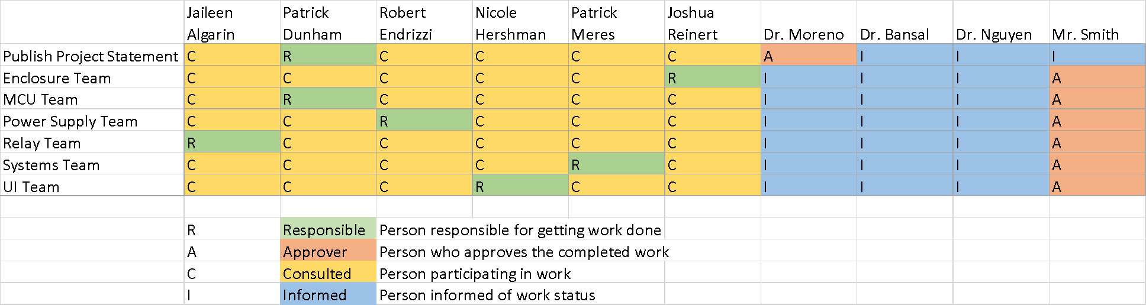

*Figure 2.3: RACI Chart*

# Theory

## Basic Circuit Theory

Circuit theory is a set of abstractions used to describe complex electrical systems using simple, modular components and procedures. By using circuit elements connected together in large networks and considering Kirchhoff’s Laws, it is possible to analyze electrical circuits without ever considering the much more complex set of Maxwell’s Laws.6

Basic circuit theory describes 3 basic components: the resistor, the capacitor, and the inductor.5 These three circuit components, in combination with independent and dependent voltage and current source, can be used to construct a large array of circuits, including voltage dividers, wheatstone bridges, and even complex passive filters. By using the relationship between current and voltage for each component, as well as Kirchhoff’s Laws, a system of linear differential equations can be found for any given circuit. Table 3.1 briefly summarizes each of these linear circuit components, including their schematic symbols, and governing equations.

*Table 3.1: Summary of Linear Circuit Components3,5*

|  |  |  |  |
| --- | --- | --- | --- |
| Name: | Symbol: | Governing Equation: | Governing Property: |
| Independent Voltage Source | 240px-Voltage_source_2.svg.png |  | Voltage, V [V] |
| Independent Current Source | 240px-Current_source.svg.png |  | Current, I [A] |
| Resistor | 2000px-Resistor_symbol_America.svg.png |  | Resistance, R [] |
| Capacitor | 240px-Capacitor_Symbol.svg.png |  | Capacitance, C [F] |
| Inductor | 240px-IEC_Inductor.svg.png |  | Inductance, L [H] |
| Current Dependent Current Source | 240px-Controlled_Current_source_2.svg.png |  | Proportionality Constant, K [$\frac{A}{A}$] |
| Voltage Dependent Current Source | 240px-Controlled_Current_source_2.svg.png |  | Proportionality Constant, K [$\frac{A}{V}$] |
| Current Dependent Voltage Source | 240px-Controlled_Current_source.svg.png |  | Proportionality Constant, K [$\frac{V}{A}$] |
| Voltage Dependent Voltage Source | 240px-Controlled_Current_source.svg.png |  | Proportionality Constant, K [$\frac{V}{V}$] |

In addition to these governing equations, an understanding of Kirchhoff’s Laws is required to develop the systems of differential equations. Kirchhoff’s Voltage Law (3.1) states that over any closed loop through a circuit, all voltage drops will sum to zero.

$\sum_{k=1}^{n}{}V_{k}=0; for a loop with n components (3.1)$

$V_{k}- Voltage drop over circuit element 'k'$

Kirchhoff's Current Law (3.2) states that all currents entering a point in a circuit must sum to zero.

$\sum_{k=1}^{n}{}I_{k}=0; for a point connected to n components (3.2)$

$I_{k}- Current flowing through circuit element 'k'$

Using these two laws, in combination with the governing equations in Table 3.1, it is possible to find an equation describing the voltage over or current through any component in the circuit, as long as all the governing properties are known. In addition, once the voltage over and current through a component have been calculated, the power dissipated/generated by that component can be calculated.

## Semiconductors

### Basic Theory of Operation

Semiconductors, along with conductors and insulators, make up the three possible classifications of electrical conductivity. While conductors have effectively zero resistance, and insulator have effectively infinite resistance, semiconductors, like germanium and silicon, lie somewhere in between.

Semiconductors can be combined with other elements in a process called “doping”, to give them an atypical number of electrons. Semiconductors with an excess of electrons are known as “N-doped” silicon, while semiconductors with a deficit of electrons are known as “P-doped” silicon.2 When these two types of doped semiconductors are combined in different ways, it is possible to make them function as either insulators or conductors depending on the electrical impulses they are subject to. These devices are incredibly useful, and have an extraordinarily wide range of effects. Unfortunately, unlike the circuit components discussed above, they are highly nonlinear. However, even though they tend to be more difficult to analyze and use, it would be impossible for modern society to exist without them.

While there are many useful semiconductor devices, this report will focus primarily on diodes, Metal-Oxide Semiconductor Field-Effect Transistors (MOSFETs), Silicon-Controlled Rectifiers (SCRs), and Triodes for Alternating Current (TRIACs).

### Diode

The diode is the most basic of all semiconductor devices. It consists of a single combination of P-doped and N-doped semiconductors, termed a P-N junction. The basic structure of a diode, along with its schematic symbol, is displayed in Figure 3.1.

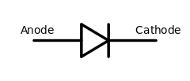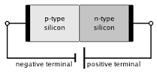

*Figure 3.1: Diode schematic and structure*

While the workings of the P-N junction are shockingly complex, the current through a diode can be related to the voltage across it through the Shockley Diode equation (3.3)2.

Vd and Id represent the voltage drop across and the current through the diode, respectively. Is and n, known as the reverse bias saturation current and ideality factor respectively, are properties of a specific diode.2Vt is the thermal voltage, and is a function of temperature. As can be seen, the relationship between current and voltage is anything but linear.

While the Shockley Diode equation is useful for accurate computation of the voltage across and current through a diode, for applications that don’t require great precision, it is simpler to think of a diode as a one-way valve for current. In this sense, a diode only allows current to flow from anode to cathode, while blocking any current from flowing in the other direction. When the diode allows current to flow, there is a roughly constant voltage drop, which is around 0.7 V for silicon diodes.

Light-emitting Diodes, also known as LEDs, are a special variant of diode that produce visible light proportional to the power they dissipate.2 These light source tend to be highly efficient and long lasting, making them ideal for use as indicator lights. They function exactly like other diodes, but have a significantly higher voltage drop, typically between 1.8 V and 3.2 V.

### Silicon Controlled Rectifier (SCR)

Silicon controlled rectifiers, or SCRs, are also known as thyristors. Composed of two P-N junctions combined together, SCRs are very similar to diodes, with one very important difference.

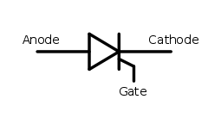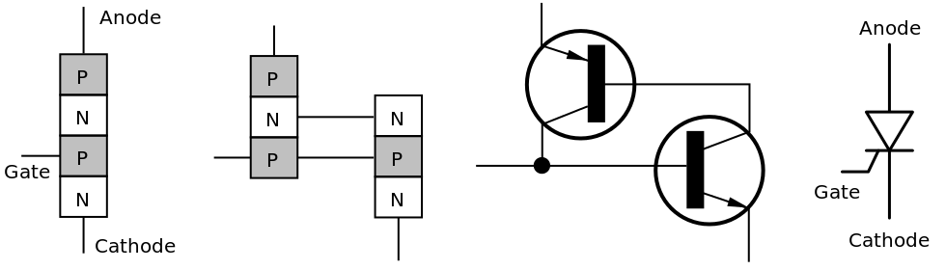

*Figure 3.2: SCR schematic and structure*

As can be seen in Figure 3.2, the SCR appears much like a diode, but with the addition of a third pin, labeled as the gate. With the gate pin at a low input voltage, the SCR will not allow current to flow in either direction. However, once a higher input voltage is applied to the gate, the SCR begins functioning like a diode, allowing current to flow in only one direction.2 The SCR will not turn off until current stops flowing of its own accord.2

Because there is no way to turn off an SCR manually, they are commonly used for rectification of alternating current (AC) into direct current (DC), as the alternating current will have regular, but brief periods of zero current, regularly shutting off the SCR.4 SCRs have also found use in switching AC. While a single SCR is incapable of switching AC by itself, two SCRs, oriented in opposite directions and controlled together, can be used to effectively switch AC.4 At any given moment, one of the two SCRs will allow the AC to flow. However, it is uncommon to see two SCRs used in such a fashion, due to the existence of the TRIAC.4

### Triode for Alternating Current (TRIAC)

Triodes for Alternating Current, or TRIACs, are variants of SCRs. They can be thought of as two SCRs connected back-to-back in parallel, as can be seen in Figure 3.3.

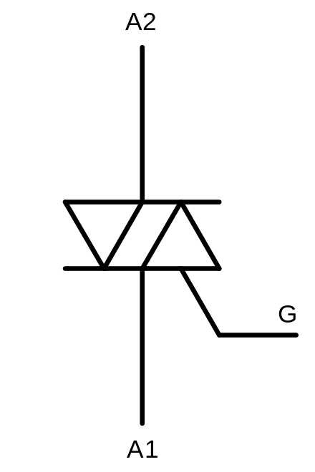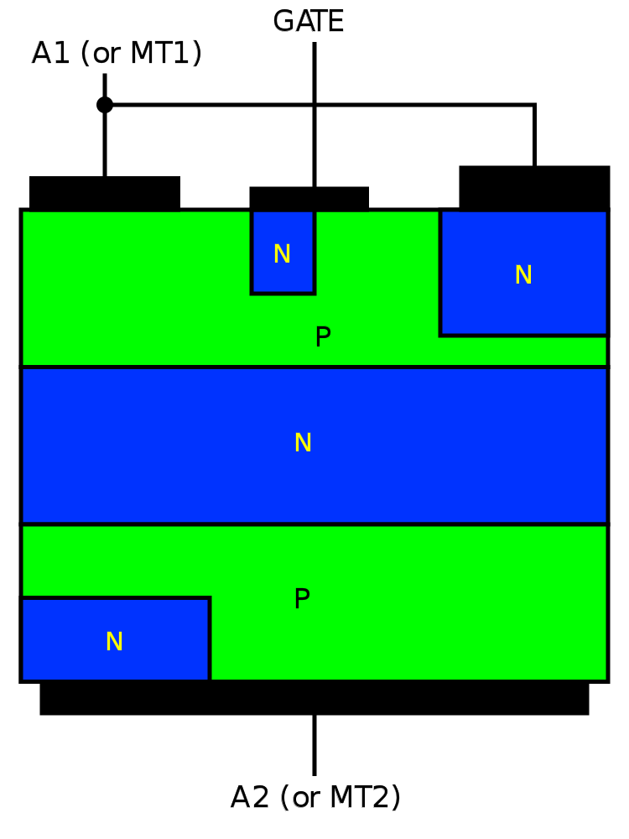

*Figure 3.3: TRIAC Schematic and Structure*

This construction allows for a single device that can properly control AC. Like an SCR, if there is a low/zero voltage at the gate pin (labeled G), the TRIAC will not allow current to flow in either direction. However, when a high voltage is applied to the gate, the TRIAC will begin conducting. Just like with the SCR, there is no way to turn the device off, other than for current to stop flowing.

### MOSFETs

Metal-oxide-semiconductor field-effect transistors are very similar to another semiconductor device known as a bipolar junction transistor (BJT), but for most uses MOSFETS are superior, due to their lower current requirement on the gate pin.1

*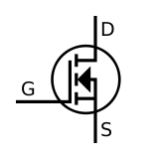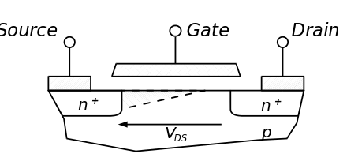*

*Figure 3.4: MOSFET Schematic and Structure*

MOSFETs function much like the TRIAC described above, in that they also do not let current flow when there is a low/zero voltage on the gate pin. When a high voltage is applied, MOSFETs allow current to flow. However, when the high voltage is removed, the MOSFET turns off. There is no need for the current to be cut off externally. As the device can be turned off manually, MOSFETS are very popular for use in controlling DC.4 Since DC never has zero-current periods, it would be impossible to control with a TRIAC.

## Microcontrollers

Microcontrollers are small, low-power, low-cost computers designed for use in embedded hardware, like washing machines, microwaves, and cars.7 Ideally, when they work properly, the end-user won’t even know they exist. Unlike microprocessors, such as the Intel Core i3, i5, and i7 devices found inside many personal computers, microcontrollers do not focus on performing complex mathematical operations. Rather, they focus on interacting with the real world. As a result, the typical microcontroller has a number of inputs and outputs, used to measure and communicate with the world around it.

For this senior design project, the ATMEL ATSAMD21G18A microcontroller has been chosen, due to its low cost and impressive feature set.. A summary of the capabilities of this device can be viewed in Table 3.2, next page, while a comparison between it and other, similar, devices can be seen in Table 4.1 on page 22.

*Table 3.2: ATSAMD21G8A Summary (From ATMEL Website)*

|  |  |
| --- | --- |
| Flash Memory [kByte]: | 256 |
| SRAM [kByte]: | 32 |
| SPI [Max]: | 6 |
| I2C [Max]: | 6 |
| USART [Max]: | 6 |
| General Purpose I/O [Max]: | 38 |
| Analog Inputs [Max]: | 14 |
| Analog Outputs [Max]: | 1 |
| PWM Outputs [Max]: | 20 |
| Interrupts [Max]: | 16 |
| Hardware Timers: | 6 |

Compared to other devices in the same $2-$4 price range, this microcontroller has an extremely large amount of Flash memory and SRAM (Static Random Access Memory). This allows space for larger, more complicated programs, as well as space to store the cycle timer’s timing data. Its ability to have up to 6 separate SPI, I2C, and USART communication ports means that it can communicate with a wide range of devices simultaneously. In addition, its large collection of analog, digital, PWM, and interrupt-capable pins allows for it to control many different devices at the same time. Its status as an ARM Cortex M0+ processor also means that the code written for this specific processor is also valid for a wide range of products from multiple companies with only minimal modifications, meaning that Capewell will not be dependent on the existence of this microcontroller.8

## Switched-Mode Power Supplies

Switched-mode power supplies, also known as switching power supplies, are an alternative to the linear power supplies that used to dominate electronics. Instead of using bulky transformers coupled with inefficient linear voltage regulators, they are designed to take advantage of the current-regulating and voltage-regulating properties of inductors and capacitors in response to transient changes.4 By rapidly switching the input power to the supply on and off, the switched-mode power supply is able to generate a controlled output voltage. Depending on the topology of the power supply (buck, boost, buck-boost, flyback, etc.) the output voltage can be lower or higher than the input voltage. Certain converter topologies, such as the flyback converter, can be used to produce an isolated output, meaning there is no physical electrical connection between the input voltage and output voltage.4

As most UL standards require isolation between low voltages and high voltages on the same circuit board, flyback converters are incredibly useful. Based on the topology of a buck-boost converter, a flyback converter substitutes a small flyback transformer for the typical inductor, successfully decoupling the input and output. A flyback transformer differs from a normal transformer in that the inherent inductance of the transformer is relatively large, allowing it to function as both an inductor and a transformer.4 The topology of a flyback converter can be viewed in Figure 3.5.

*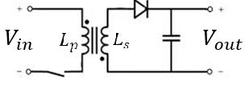*

*Figure 3.5: Basic Flyback Converter Topology*

For a simple flyback converter, the switch seen in the bottom-left of Figure 3.5 is regularly turned on and off at a constant duty cycle. This produces an output voltage proportional to the input voltage, which can be calculated using Equation 3.4, where $\frac{N_{s}}{N_{p}}$ represents the ratio of turns in the flyback transformer and D represents the duty cycle of the switch.

$V_{out}=V_{in}*\frac{N_{s}}{N_{p}}(\frac{D}{1-D}) (3.4)$

$V_{out}-Flyback converter output voltage$

$V_{in}-Flyback converter input voltage$

$\frac{N_{s}}{N_{p}}-Flyback transformer winding ratio$

$D-Flyback Converter duty cycle$

During each on cycle of the switch, the flyback transformer shown in the center of Figure 3.5 is first “charged up” by the input voltage. While the flyback transformer is charged, the capacitor supplies a voltage to the load connected to the output. During the off cycle, the flyback transformer discharges, supplying power to the load at the output and recharging the capacitor.

A more complex switching power supply, with a control loop regulating the duty cycle of the switch, can be used to precisely control the output voltage for a range of input voltages.4 It is possible to build a switching power supply that can deliver a constant voltage output over a range of 90 V - 250 V input.

## Manufacturing

### Printed Circuit Boards (PCBs)

PCBs are typically a slab of nonconductive material with many electrical components mounted on top of it and connected to each other by conductive copper paths. After proving a circuit configuration on test boards, PCBs can be made that will incorporate all of the necessary components into a more compact and streamlined form factor that can be more easily mass produced. The PCB can also allow certain components to be added after board production on an as-needed basis. This modularity may allow for the same board to replace multiple sizes of mechanical cycle timers since connections could be added or removed as needed.

### 3D Printing

3D printing is the process of creating three-dimensional objects by layering a substrate on top of itself repeatedly. It is more commonly done with types of plastic but can also be done with specialized metal solutions and called additive manufacturing. 3D printing is typically preferred for rapid prototyping as a design can be quickly and relatively cheaply made to proper scale to see if it fits the requirements for size or shape before production by other means.

### Injection Molding (Plastic)

Injection molding involves heating a plastic or polymer and forcing it into a mold. It can be especially cheap to method to produce small parts rapidly as long as plastic is an acceptable material.

### Casting

Casting is a type of injection molding that involves pouring a liquified material into a mold and then solidifying it. For example, metal could be melted, poured into a mold, and then cooled to obtain a desired shape. It is more commonly used to make complex shapes.

### Sheet Metalworking

Sheet metal can be any of several different types of metals or alloys that are formed into thin sheets and ductile enough to be manipulated into desired shapes. Aluminum, steel, copper and brass are some common materials made into sheet metal. Aluminum is a very common choice because of its relative low cost, ease of manipulating and corrosion resistance.

Marktime’s current cycle timers sit on a sheet of aluminum. Aluminum would likely be the preferred material for the new cycle timer to be mounted on since it has already been demonstrated to work well in the environment by the current models. In addition, aluminum’s heat dissipation properties may be beneficial to an electrical system with components that are only rated to function in certain temperature ranges and given that the anticipated maximum ambient temperature is 60°C.

# Design/Analysis

## Enclosure

Going to a circuit-based timer allows for a lot of flexibility in the shape and size of the device. For simplicity and to maximize compatibility with current systems, the team was directed to make the cycle timer fit in the same footprint as the current electromechanical model. Mr. Andrew Smith from Capewell provided the team with drawings of several models of various numbers of switches, including multiple models that had the same number of switches. The dimensions were consistent across timers of the same number of switches. Dimensions were also provided for the mounting hole locations. The mounting holes have a radius of *0.085 inches* and and can be used to fix the plate into the control units by simply pinching with a bolt and nut. The electromechanical timer sits on an aluminum frame that raises about *0.313 inches* from the height at which the mounting holes are located. For the solid-state timer, mounting the circuit on top of this thicker layer of aluminum may be beneficial for conducting heat off of the circuit board. A picture of an electromechanical cycle timer with 8 switches is shown below in Figure 4.1.

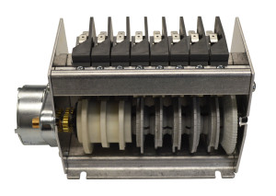

*Figure 4.1: Picture of the Electromechanical Cycle Timer with the dimension of .313 in. given between the bolting hole height and where the cycle timer hardware begins. The bolt holes with 0.085 in. radius are the visible cutouts.*

There are heat concerns due to it being an electrical system switching on and off electrical loads of higher voltage and amperage. The circuit elements are typically rated to work in a range of temperatures for a given number of cycles. Since the ambient temperature could be as high as 60°C the circuit elements will already be closer to their maximum rated temperatures in the off-state than a typical home electronic. Exceeding the ratings could result in reduced life span of the part or damage to the entire cycle timer system. Once the first circuit is printed and working, temperature readings will have to be taken while the circuit is functioning and in a simulated environment. If additional heat dissipation is needed some type of additional heatsink may need to be added to the affected components. This would most likely be a finned block of aluminum for cost-effectiveness. In order for this product to be viable as a replacement to the current electromechanical timer cost must be minimized. Fans would be avoided if possible due to their additional cost and shorter effective lifespans.

From discussion with the sponsor, the mounting platform will not be subjected to any stresses or extreme vibrations. The pumps and water jets of the dishwasher should not affect the electronics inside the control unit. Similar dimensions of materials for the mounting platform as the existing product would ensure structural integrity in the new product. It will simply sit inside the dishwasher control unit which is sufficiently protected from water to house other exposed electronics. Mechanically, size and the ability to attach it inside the control unit are the primary concerns.

## Microcontroller

The microcontroller design group consists of both a hardware component and a software component. To determine the microcontroller to use, three common microcontrollers designed by Atmel were compared. The results of this comparison can be seen in Table 4.1. As can be seen, the ATSAMD21G18A is far more capable than the other two microcontrollers

*Table 4.1: Microcontroller Comparison*

|  |  |  |  |
| --- | --- | --- | --- |
|  | *ATMEGA328P* | *ATMEGA32U4* | *ATSAMD21G18A* |
| *Price* | *0* | *-* | *+* |
| *Program Memory* | *0* | *0* | *+* |
| *RAM* | *0* | *0* | *+* |
| *USB* | *0* | *+* | *+* |
| *Operating Freq.* | *0* | *0* | *+* |
| *GPIO Count* | *0* | *+* | *+* |
| *Ease of Use* | *0* | *0* | *-* |
| *Total* | *0* | *+1* | *+5* |

To begin, a development board designed by Sparkfun Electronics (Figure 4.2) is used in place of an individual ATSAMD21G18A microcontroller with custom support circuitry.

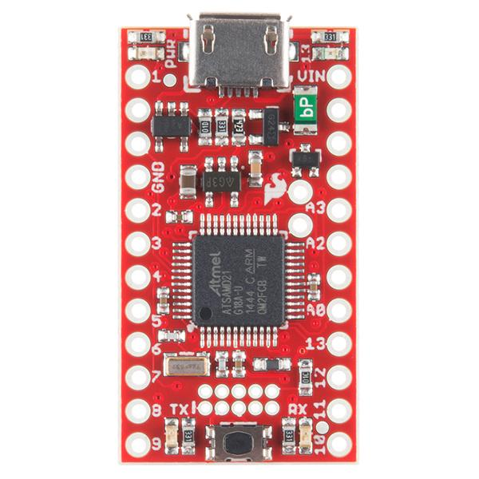

*Figure 4.2: Photo of the ATSAMD21 Sparkfun Development Board*

This development board uses the same microcontroller that will be used in the final project, and is preassembled with all the required support circuitry. This allows for focus to be placed on the development of the firmware for the microcontroller, which is the heart of the solid-state timer. As the relays the microcontroller is required to control are part of a separate section of the project, the Sparkfun development board is instead connected to 8 light-emitting diodes (LEDs). Both the LEDs and the relays require more current to turn on than the microcontroller is capable of outputting. Therefore, a MOSFET is connected to each pin of the microcontroller required to control a relay. This MOSFET allows the microcontroller’s output pins to switch on and off a far larger current than they are normally capable of, in a similar way to the relays they control. Use of LEDs also greatly simplifies debugging of the solid-state time firmware, as it is far easier to verify that the light is on or off than it is to check the output voltage on a relay. The test circuitry assembled on the breadboard can be viewed in Figure 4.3.

*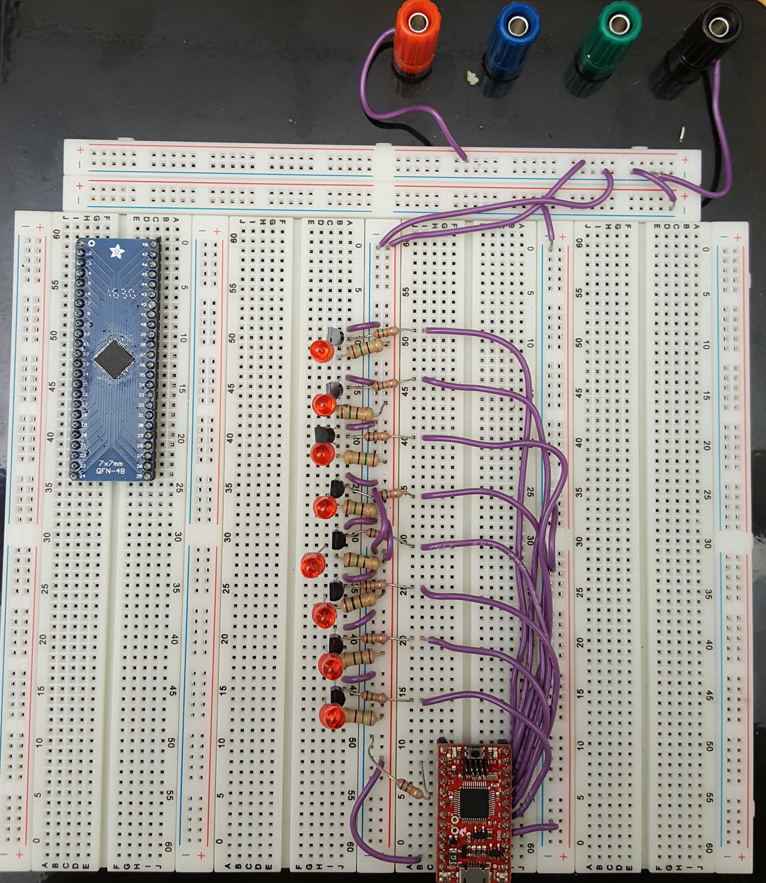*

*Figure 4.3: Breadboard with Sparkfun Development Board*

The small red board in the lower center of Figure 4.3 is the aforementioned Sparkfun development board, while the larger blue board in the upper left hand corner is an ATSAMD21G18A microcontroller mounted in a breadboard adapter. The row of components running down the center of the board is the collection of 8 LEDs representing the relays connected to the MOSFET protected microcontroller outputs.

While the Sparkfun development board is incredibly useful for prototyping, it cannot be reliably used in the final design, as it is far more expensive than the parts suggest. Therefore, it is necessary to integrate all the required support circuitry into the PCB that will become the solid-state timer. This support circuitry primarily consists of power supply filter capacitors, an external crystal oscillator, connections to the USB port and programming port, and connections to the required ground and 3.3V. To discover exactly what is required, the Atmel ATSAMD21 datasheet is referenced. Here, detailed recommendations, sample circuitry, and component values are provided. In addition, as the Sparkfun development board is classified as Open Hardware, its schematic is used to provide further advice on exactly how the circuitry must be designed. The only addition to the circuitry specified in the Atmel ATSAMD21 datasheet is the addition of the aforementioned MOSFETs on each output. For these, a simulation in a SPICE program is constructed, and the output of the MOSFET switch is verified. The MOSFET schematic can be viewed in Figure 4.4.

*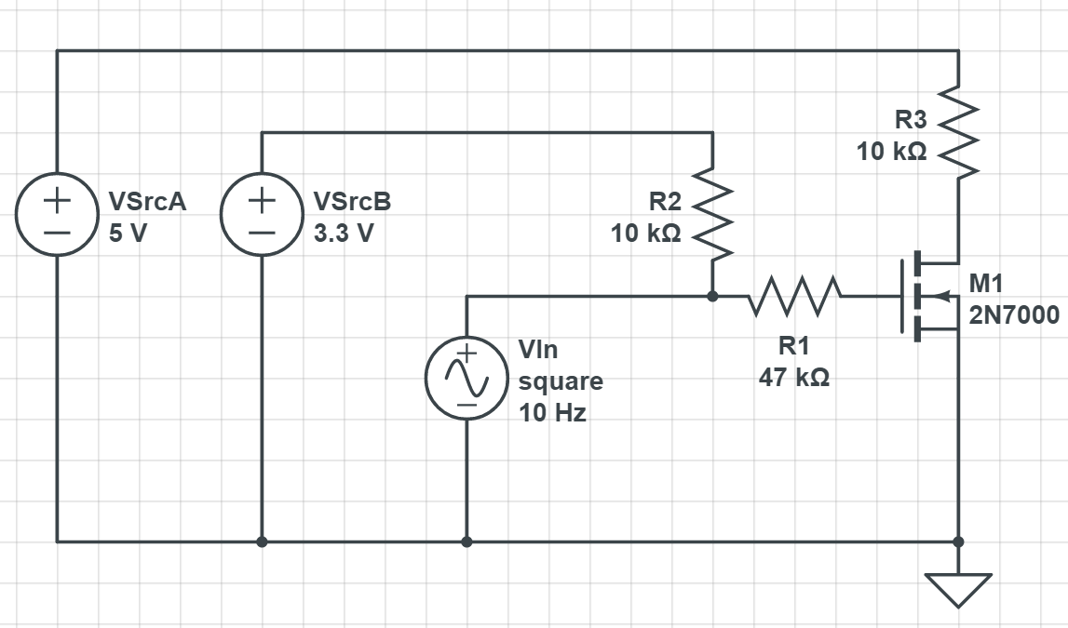*

*Figure 4.4: MOSFET Schematic for use in SPICE*

This simulation contains two reference voltages, describing the 3.3 V supplied by the microcontroller and the 5 V used to turn on the relays. The VIn source is a 10 Hz square wave, alternating between the 3.3 V “on” state of the microcontroller pins and the 0 V “off” state. R3 represents the load the MOSFET is controlling, while R2 and R1 provide the proper voltage biasing for the MOSFET gate pin.

The design of the code is based on a simple state machine describing the operation of the timer. This state machine, depicted in Figure 4.5, consists of three states: the Idle state, the Cycle state, and the Reset state.



*Figure 4.5: Solid-State Timer State Machine*

The solid-state timer begins operation in the Idle state, which pauses all operation of the cycle timer and keeps all relays turned off. When the proper start condition is delivered to the solid-state timer, it enters the Cycle state, and begins operating the relays in the prescribed order. If the start condition is ever no longer detected, the solid-state timer immediately enters the Idle state, turning off all relays and pausing the cycle. This way, when the start condition is again detected, the timer picks up the cycle from the point it left off. When the cycle completes, it enters the Reset state, preparing the solid-state timer for a new cycle. The reset state immediately proceeds to the Idle state once everything is refreshed.

To make sure the state machine, the most important portion of the code, is implemented correctly, the Arduino development environment is used. It contains pre-built functions for accessing the microcontroller’s hardware, making it easy for unfamiliar users to develop applications. Then, once the state machine logic is complete and tested, the more advanced Atmel Studio can be used to replace the pre-built Arduino functions with more efficient, application-specific functions. This process helps to reduce code size and complexity, allowing for future users of this project to expand the functionality of the solid-state timer with ease.

Once the state machine code is verified, the Sparkfun development board is replaced with an individual ATSAMD21G18A microcontroller, and the support circuitry specified in the microcontroller schematic is constructed on a breadboard. This construction state represents the current level of progress on the microcontroller. Once the breadboarded circuit has been tested, the schematic for the microcontroller support circuitry will be integrated into the final PCB design.

## Power Supply

The initial plan for the power supply was to use a pre-built flyback converter configured to convert an AC voltage between 90 V - 250 V to a DC voltage of 5 V followed by a linear regulator to provide a voltage to 3.3 V. While simple, this solution is expensive. To replace it, a custom multi-stage switched-mode power supply has been proposed. This switching converter will first use a completely isolated flyback converter to drop the same range of input voltage to 12 V DC. The second stage will consist of two buck converters which will lower the 12 V DC to 5 V DC and 3.3 V DC, respectively. A block diagram created from Texas Instrument’s (TI’s) online power supply design tool, known as WEBENCH, can be seen in Figure 4.6.

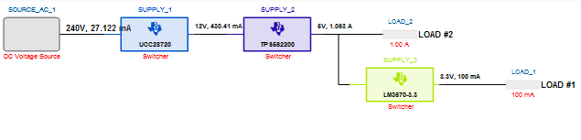

*Figure 4.6: Custom Power Supply Block Diagram*

This solution, while requiring more design work, will be noticeably less expensive. The isolated first stage is a UL safety requirement for boards working with both high and low voltages. To prevent dangerous electric shock, there must be no physical electrical connection between the high voltage and low voltage sections of the board. This means that a small transformer, like the one present in a flyback converter, is used to decouple the two voltages. A schematic, again generated by WEBENCH, can be viewed in Figure 4.7.

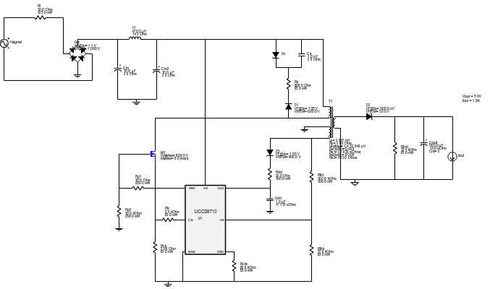

*Figure 4.7: Custom Power Supply First Stage - Flyback Converter*

The first portion of the flyback converter, seen in the upper left section of Figure 4.7 converts the AC input voltage to DC. This DC voltage is then fed through a set of filters before entering the flyback transformer. This transformer has one primary winding and two separate secondary windings, and is designed to have a higher-than-average inductance. The first secondary winding is connected to the remainder of the flyback converter, and provides the 12 V DC output. The other secondary winding feeds back into the controller circuitry, providing output feedback while preserving isolation. The controller circuitry, seen in the bottom left corner, switches on and off the transistor in blue, which regulates the output voltage level.

The second stages will be two buck converters. These converters, which follow a similar, but transformerless, topology to the flyback converter above, step down the voltage of the first stage to the voltages required by the microcontroller, user interface, and relay control. A schematic, generated by WEBENCH, can be viewed in Figure 4.8.

**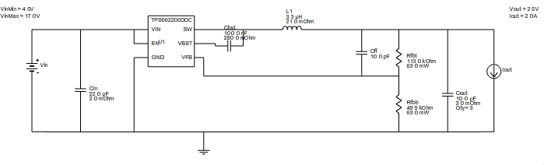**

*Figure 4.8: Custom Power Supply Second Stage - Buck Converter*

Each one of the secondary stage buck converters follows the form seen above. The integrated circuit seen at the left side of the schematic contains both the control circuitry and the transistor switch, making for a compact circuit. The rest of the circuit exists to filter the output voltage and bias the buck converter chip for the proper output voltage.

This schematic is currently being transferred to PSpice, so that simulation of the output can be performed to verify that the replacement will meet expectations. This represents the current level of progress on the power supply. Once the output of the simulation is verified, the parts to construct the power supply will be sourced and tested on a breadboard. If the breadboard prototype matches expectations, the design will be added to the final solid-state timer PCB.

## Relay

The relay component of the project is rather complicated, as the desire for solid-state circuitry prohibits the use of simple electromechanical relays. Instead, a solid-state replacement must be used. To decide which replacement to use, each of the three options considered (TRIAC, SCR, Premade Solid-State Relay) are compared to the default electromechanical relay. This comparison can be viewed in Table 4.2 below.

*Table 4.2: Solid-State Relay Comparison*

|  |  |  |  |  |
| --- | --- | --- | --- | --- |
|  | *Electromechanical Relay* | *SCR* | *TRIAC* | *Premade Solid State Relay* |
| *Cost (2x)* | *0* | *+* | *+* | *-* |
| *Ease of Use* | *0* | *-* | *-* | *0* |
| *Performance* | *0* | *0* | *0* | *0* |
| *Reliability (2x)* | *0* | *+* | *+* | *+* |
| *Part Count* | *0* | *-* | *0* | *0* |
| *Total* | *0* | *2* | *3* | *0* |

As can be seen in the table above, the TRIAC is the best of all solid-state relay options.

To properly control the TRIAC, support circuitry is required to make sure it switches on and off in the desired fashion. In addition to the support circuitry, UL requirements demand isolation between the high and low voltages sections of the board. Therefore, an optical isolation circuit, or optoisolator is included between the gate of the TRIAC and the output of the microcontroller. The resulting schematic for the relay design can be viewed in Figure 4.9, below.

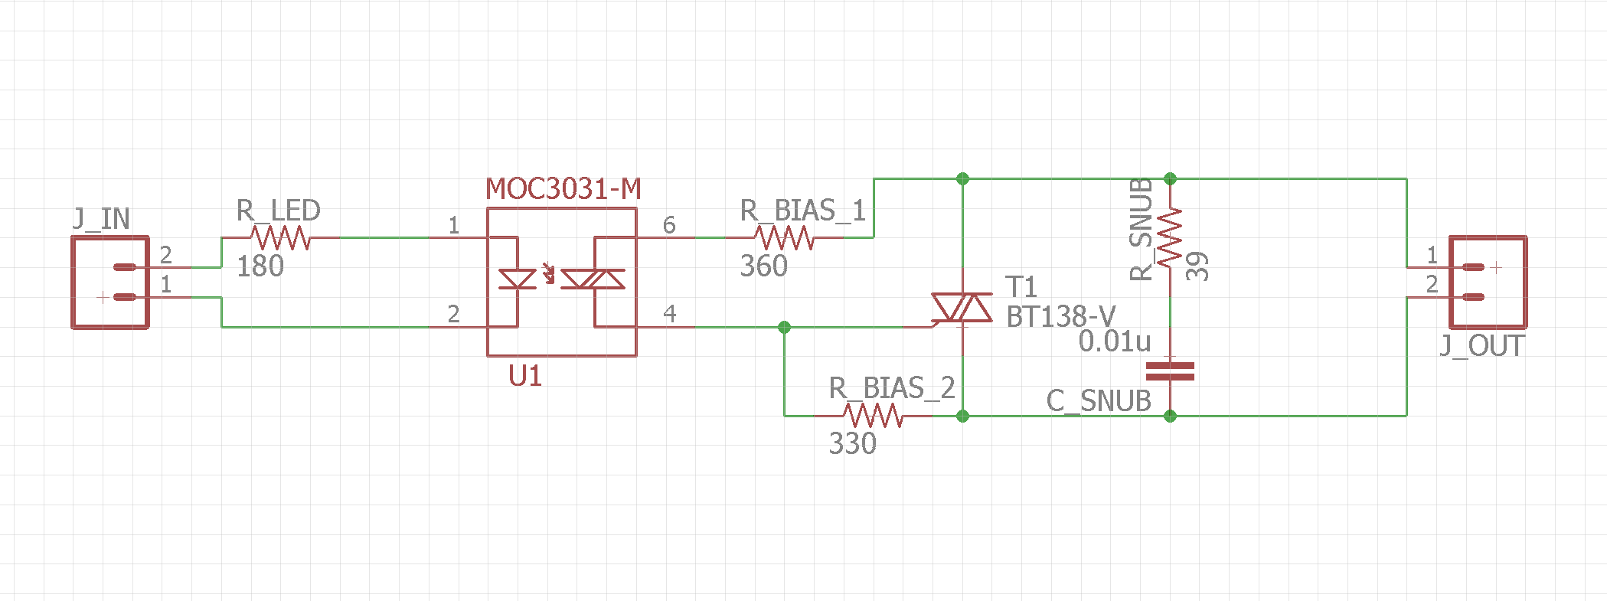

*Figure 4.9: Solid-State Relay Schematic*

A similar schematic, with J\_IN replaced by a 5V voltage source and J\_OUT replaced by a load element, is used in PSpice to perform simulation of the output of this relay. In place of the microcontroller output, a voltage pulse of the same voltage level is used. The output of the relay is then plotted for a number of different resistive and inductive loads with a current draw between 1 and 15 A. This represents the current level of progress with the relay component. Once the TRIAC and support circuitry is fully assembled, the output of the relay will be measured for the same type of loads plotted in PSpice. If the results are similar, the schematic will be added to the final solid-state timer PCB.

## User Interface

It was requested by Capewell that there be two separate methods of controlling the cycle time and relay outputs, to allow for factory settings to be programmed quickly, but also allow users to customize their timers for individual use. The company sponsor indicated that for the end-user interface, a visual method would be greatly preferred. It was decided that the use of a monochrome graphic LCD would be simple to use, cost effective, and easy to understand. For the factory interface, it was decided that USB would make the most sense, as the chosen microcontroller has the USB protocol built in. This would allow for the initial settings to be uploaded by a computer, and have the process be completely automated.

To simplify the design of the user interface (UI), a pre-built LCD module is used. The chosen display consists of a 128 x 64 grid of black and white pixels, and requires only a few wires between the built-in display controller and microcontroller. While expensive, it is likely out of the scope of this project to design the support circuitry for a monochrome graphic LCD. The chosen display module is visible in Figure 4.10.

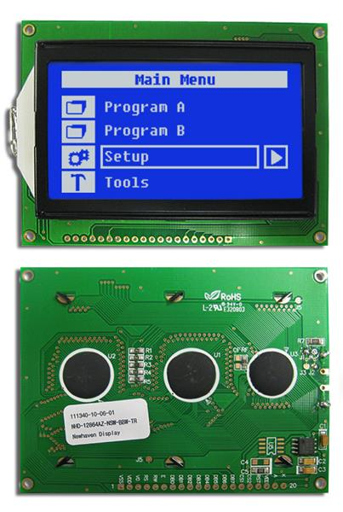

*Figure 4.10: Monochrome 128 x 64 Graphic LCD*

As there is no support circuitry to speak of, there is no simulation required. However, the appearance of the UI must be determined so that it is simple to understand with minimal explanation. For display mockups, Microsoft Paint is used to fill in individual pixels. While by no means a professional design program, it is the easiest way to quickly and accurately duplicate what will appear on the display. Two different designs were created, and displayed to the faculty advisors with no explanation. They were asked to determine what each display was referencing, and whether or not they could interpret how the displays could be used. These designs can be viewed in Figure 4.11. Larger versions of each design are present in Appendix C.

*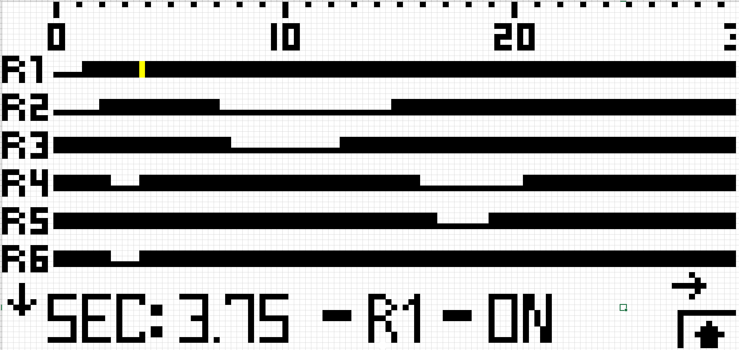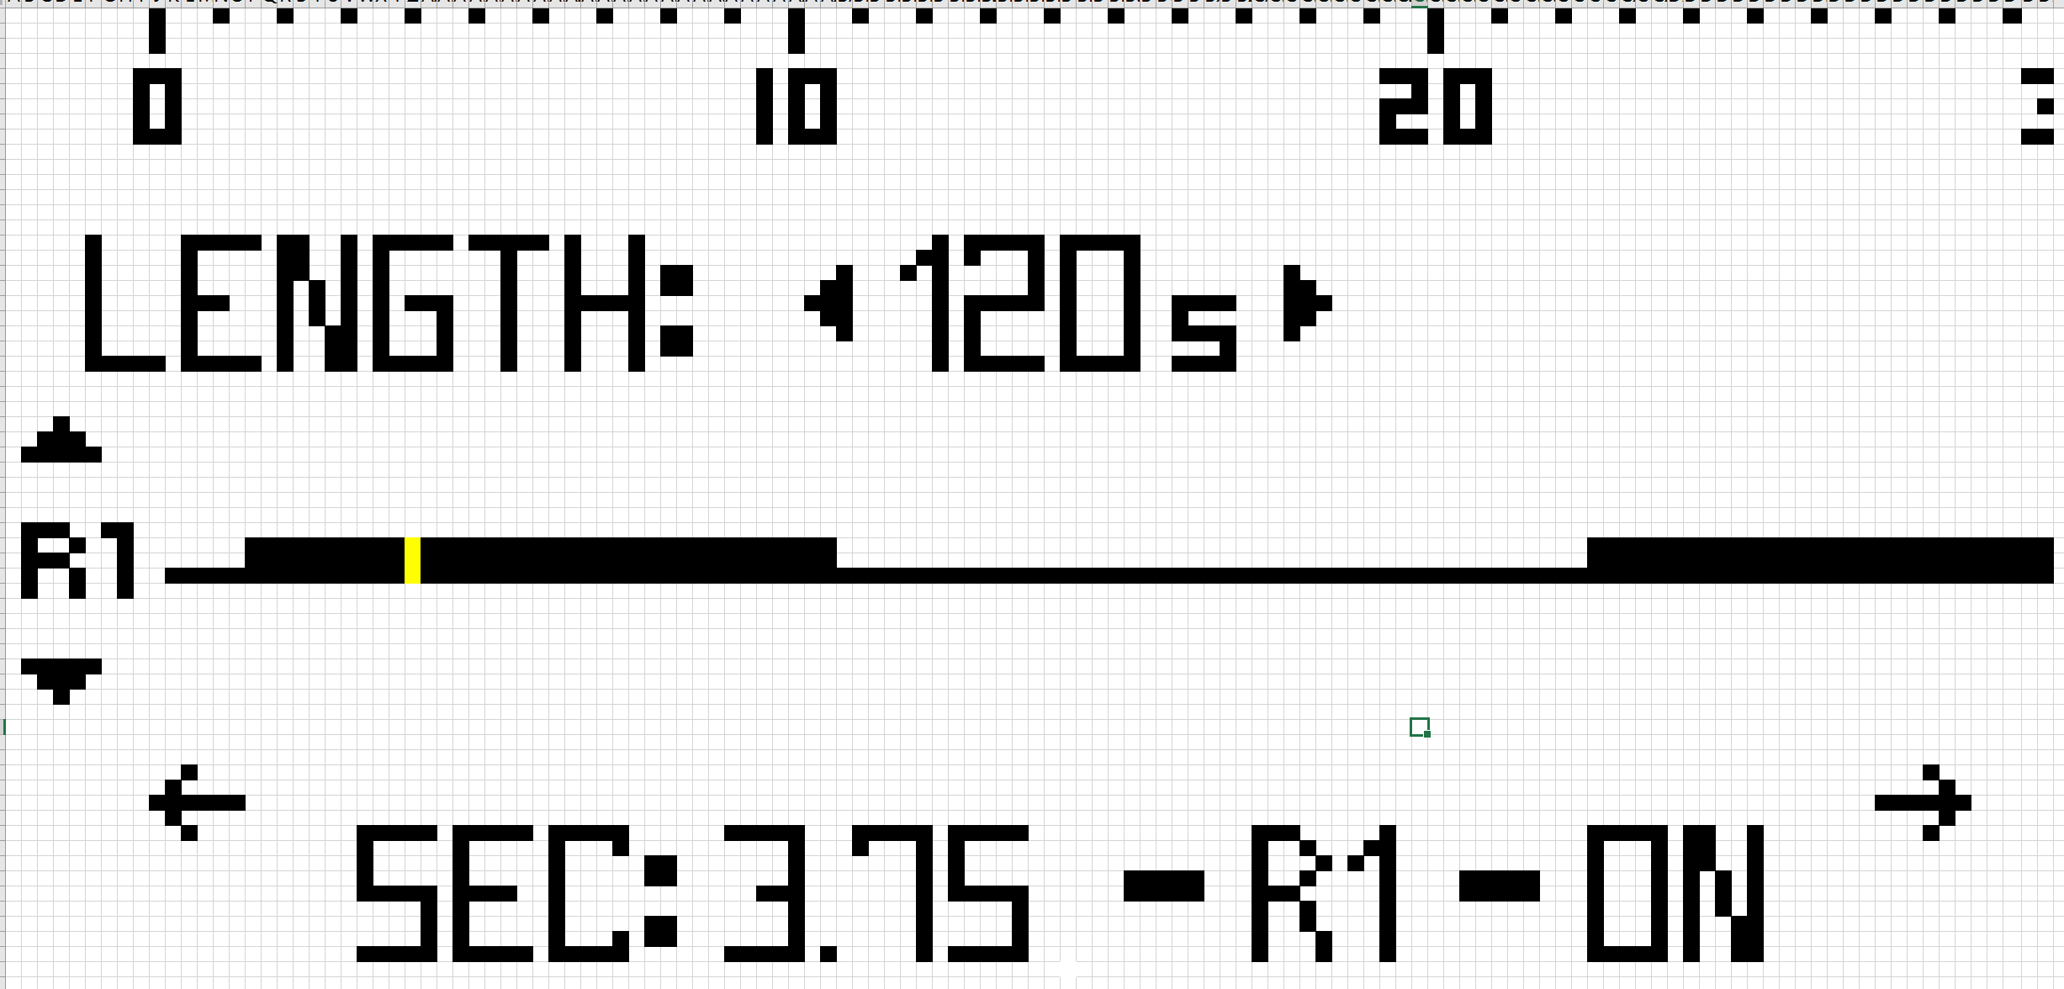*

*Figure 4.11: Display Mockups*

With the input of the faculty advisors, it was determined that the best interface would be a combination of the two, with the image on the left used as the “default” view, displaying as many timers as possible, and the image on the right used as the “edit” view, allowing one to change the cycle length as well as the on-off state of the selected relay.

To interact with the UI, a button pad is constructed. To continue with the trend of solid state components, as well as to promote reliability, the buttons are designed to be capacitive. This means that there are no mechanical buttons, and instead a copper pad on the PCB is used to sense the presence of the user’s finger. These buttons are commonly used in desk lamps, microwaves, and ovens, and can survive a virtually unlimited number of button presses. A 5-button arrangement is chosen, with 4 directional keys and one select key, allowing for simple navigation throughout the UI. The button layout can be viewed in Figure 4.12.



*Figure 4.12: Button Pad Layout*

Currently, the button pad prototype is being constructed from cardboard, copper tape, and paper, and will be interfaced with the microcontroller shortly. This represents the total level of progress on the UI component. Next, code will be written to monitor button presses, and to display the desired graphics on the LCD module. Finally, room will be made on the final solid-state timer PCB for the LCD and the properly shaped copper pads.

# Results

## Enclosure/Mounting Platform

The mounting platform for the 8-switch-sized timer is modeled below with Autodesk Fusion 360. The diameter of the bolt holes is *0.17 inches*, the distance between bolt centers is *3.66 inches*, the total width of the plate is *4.66 inches*, the depth of the plate is *2.72 inches*, the depth of the raised section of plate is *2.00 inches*, the height of the bolt mounting layer of the plate is *0.063 inches*, and the total height of the plate is *0.375 inches*.

From the review of manufacturing techniques previously, aluminum sheets will continue to be used as the mounting plate material. Aluminum is lightweight and its thermal conductivity may help conduct heat away from the circuit board. Sheets are also inexpensive and easy to work with. It is also strong and durable so any vibrations the control unit may experience when the dishwasher is running will not cause fatigue concerns in the mounting platform. It has desirable properties and is proven effective in the current electromechanical timer.

**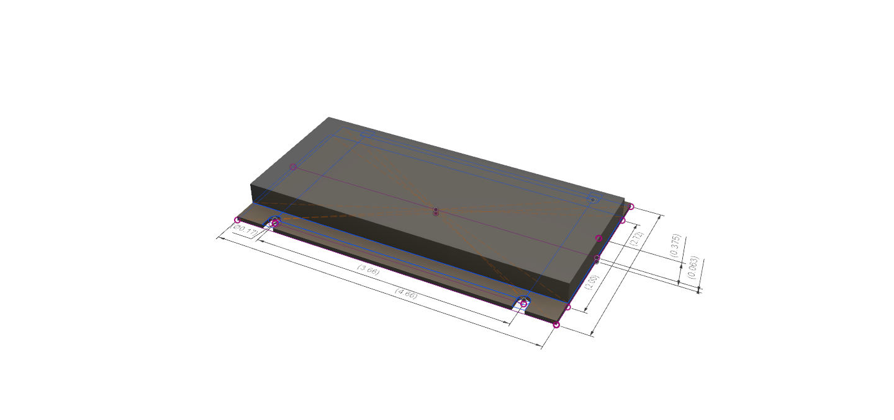**

*Figure 5.1: CAD Model of Simple Mounting Platform (8-Switch Size)*

The width dimensions for 6-, 7-, and 8-cam timer plates is given in Table 5.1, below. All plates have the same depth and height.

*Table 5.1: Widths of Mounting Plates for 6-, 7-, and 8-cam Timers*

|  |  |  |
| --- | --- | --- |
| # of cams | Dimension (in.) | |
| Total Width | Bolt Separation |
| 6 | 3.72 | 2.73 |
| 7 | 4.19 | 3.20 |
| 8 | 4.66 | 3.66 |

## Microcontroller

As stated in the Design/Analysis section, the microcontroller portion of the project currently has the state machine code complete and tested, as well as a complete schematic. The full source code can be viewed in Appendix A, and the full schematic can be viewed in Appendix B.

The source code, is divided into two primary functions. The first, entitled setup(), is run once when the device is turned on. This loop initializes all necessary hardware components, including the output pins, hardware timers, and USB port. The second, entitled loop(), runs repeatedly until the microcontroller is shut off. This second function checks to make sure the start condition for the cycle is present, and updates the state machine at a regular interval. The state machine, however, is where the relay control takes place.

As stated in Section IV, the source code implements a state machine with three states: an Idle state, a Cycle state, and a Reset state. When in the Idle state, the code only checks to see if the start condition has taken place. If it has, it advances to the Cycle state. Otherwise, it remains in the Idle state. When in the Cycle state, the relays begin to turn on. All relay states for each time interval are stored in a large array of 32-bit variables. Each variable in the array represents one time interval, and each bit in the variables represents one pin. This arrangement allows for simple setting of microcontroller pins and allows for software support of up to 32 relays with little modification. This is well beyond the desired specification, but does not hinder functionality in any way. Each time interval spent in the Cycle state increments a counter variable, which is used to call the variables from the previously mentioned array in the proper order. When a variable is called, it is used to set the relay pins to the indicated on-off state. Finally, the counter variable is compared to the current total cycle time expressed in number of time intervals. If the counter variable is equal to the total cycle time, the cycle has completed, and the system enters Reset state. When in Reset state, the relays are cleared (set to “off”) and the counter variable is set to zero. This is the only place in the code that sets the counter variable to zero. Because of this, the only way to begin a new cycle is to finish the old one, or perform a hardware reset. Otherwise, upon entering Cycle state, the timer will pick up where it left off previously.

The microcontroller schematic can be divided into a number of sections. The first, and most important, is the microcontroller itself. As can be seen in Figure 5.2, there are a large number of power supply filter capacitors connected directly next to the microcontroller’s numerous power and ground pins. In addition, a 32.768 kHz crystal is connected to the microcontroller’s external crystal pins, allowing for a 48 MHz operating frequency. To the right of the microcontroller, connections to the programming header are visible. These are extremely useful for prototyping, and will remain useful in the final project for initial programming, debugging, and in-field troubleshooting.

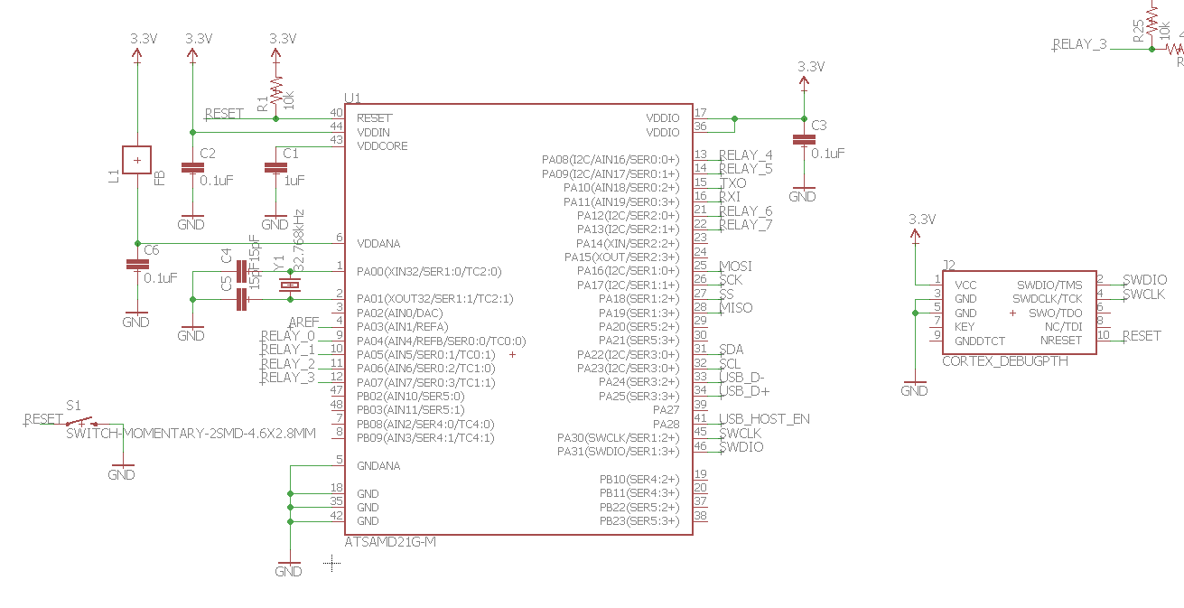

*Figure 5.2: Microcontroller Schematic - Microcontroller*

In addition to the programming header, a number of other headers and connectors are required. While only the USB and Inter-IC-Communication (I2C) headers will remain in the final schematic, the other headers are present to represent connections to other portions of the final product, such as the UI. These headers, in addition to the MOSFET output buffers, can be viewed in Figure 5.3, next page.

*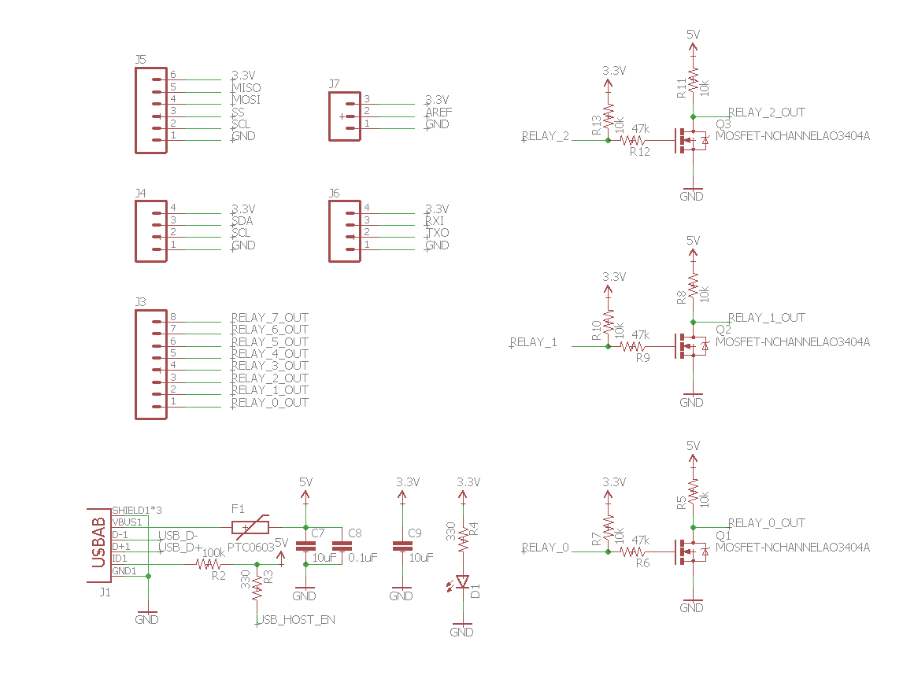*

*Figure 5.3: Microcontroller Schematic - Headers and MOSFETs*

While only three copies of the MOSFET buffers are shown, there are a total of 8 - one for each relay pins. There are a total of 6 connections shown in this figure, as well. There is one micro USB-AB connector, one I2C header, one Serial Peripheral Interconnect (SPI) header, one Universal Asynchronous Receiver/Transmitter (UART) header, and two breakout headers for the analog reference voltage pin and the outputs of the MOSFET buffers. A larger copy of the microcontroller schematic can be viewed in Appendix B.

## Power Supply

The current pre-built power supply solution has been determined to be too expensive for use in the final design. Instead, the converter topology discussed in Section IV is currently under development. Using the help of TI’s WEBENCH design tool, a preliminary schematic has been designed. However, the group has had difficulty identifying SPICE models to match the parts that WEBENCH has identified, hindering the ability to run a proper simulation. Currently the head of this section, Robert Endrizzi, is working with Professor Sung Yeul Park to remedy this solution and create the missing SPICE models.

## Relay

The solid-state relay simulation has been completed, and has returned favorable results. The output of the TRIACs has been plotted for a number of inductive and resistive loads designed to simulate motor and heating elements for a range of amperages between 1 A and 15 A. The full results can be reviewed in Appendix E, but a summary of the results can also be seen in Table 5.2 below.

*Table 5.2: TRIAC Outputs for Various Loads*

|  |  |  |  |  |  |
| --- | --- | --- | --- | --- | --- |
| *Load #:* | *Load Type:* | *Expected RMS Current [A]:* | *Simulated RMS Voltage [V]:* | *Simulated RMS Current [A]:* | *Simulated TRIAC Losses [W]:* |
| *1* | *Resistive [120 Ω]* | *1* | *119.2* | *0.995* | *20.8* |
| *2* | *Resistive [40 Ω]* | *3* | *119.1* | *2.99* | *21.3* |
| *3* | *Resistive [8 Ω]* | *15* | *118.6* | *14.9* | *35.2* |
| *4* | *Inductive [0.318 H]* | *1* | *-* | *-* | *-* |
| *5* | *Inductive [0.106 H]* | *3* | *119.0* | *incomplete* | *incomplete* |
| *6* | *Inductive [0.021 H]* | *15* | *119.4* | *24.8* | *56.4* |

Full results, including time-domain graphs of the outputs, can be viewed in Appendix E. Further analysis of the results is needed to determine if the TRIAC model is functioning as intended. Currently it does not appear so as some of the data points, indicated by a *dash*, did not converge. More work will have to be done to understand the results and the model will likely be revised.

## User Interface

The design of the user interface has been decided. A monochrome 128 x 64 LCD is used to display the data shown in Figure 5.4.

**

*Figure 5.4: Display Mockups*

The default screen, shown to the left, displays the status of as many relays as possible. If not all can fit on the screen, arrows like those shown indicate the display’s ability to scroll up and down to display them all. The black bars show the status of the relay. A thick bar indicates the relay is to be on for that length of time. A thin bar indicates the relay is to be off. The ticker along the top displays the passing time for reference. As the entire cycle will not fit on the display by itself, arrows indicate the display’s ability to scroll left and right. The small blinking yellow section on the R1 bar indicates the position of the cursor. The text on the bottom displays the cursor’s position in terms of time and relay number, as well as the relay status.

If one selects a relay, the edit screen, shown to the right, is displayed. This screen displays only one relay, and allows one to change both the relay and the total cycle length, indicated by the “Length: \_\_\_” prompt above the relay bar.

The capacitive button pad will consist of 4 directional buttons and a select button, familiar to anyone who has used an MP3 player or TV remote. This will allow one to navigate the relay bars and select where to make changes.

This interface, while easy to understand, is not ideal for initial programming or major changes. For this purpose, a USB port will be included on the final solid-state timer, and the device will be configured to appear as a virtual serial port. This will allow the factory to upload an entire timing specification via a computer.

# Schedule

Review of the Project Schedule created and revised earlier in the semester shows that the team set a very aggressive goal and underestimated the difficulty of certain tasks, but overall has enough buffer time left in the schedule that will allow the project to be finished without issue.

In all key areas of the project, it was found that moving from a design, to a model that can be successfully simulated is much more complicated than expected. This primarily comes from difficulty finding the proper libraries of components to call upon in the modeling software, as well as difficulties being able to install the correct programs and the additional libraries on the team computer in the lab. Finding the correct person to grant a team member full administrative access rights to the computer took some time, and even after finding them, it took an additional couple of weeks before the access was approved. This made it very difficult to begin collecting data as early as originally scheduled.

Delayed items have primarily been verifying schematics. As stated in Section V, Results, simulations have yet to be run for the power supply stage, but the team member responsible for it is actively working with a professor that specializes in power system design to figure out how to properly model the schematic for simulation. FInalizing the UI design with approval from faculty advisors was completed nearly a month late, and so its dependent, coding the UI, has been started later as well. Additionally, the time needed to code the MCU and UI was extended due to underestimating the complexity involved. The MCU was selected partly for its ability to be coded with Arduino if desired. This was expected to make coding the MCU operation very simple. However, finding the correct software version that could communicate with the selected MCU proved unusually difficult. It took extensive troubleshooting before the team was able to get the MCU and software development environment communicating with each other. The team originally planned to have a first PCB delivered and tested before the intersession, however with the delays in the schedule the first PCB will likely be ordered during the intersession so that it is delivered by, at latest, the end of the intersession and testing of the physical unit can begin.

A full copy of the ME Team 9 schedule can be viewed in Appendix F.

# Summary

The cycle timer development is well underway with a lot of work being done on each component. The relay system is using TRIACs and simulation results are being used to update the model. The microcontroller being used is an Atmel ATSAMD21 model. The function of the microcontroller with the assistance of a development board is being tested on a breadboard with LEDs to confirm the code and controller properly cycle power on and off to specific connections at the correct times. The user interface design has been chosen and the team member responsible for coding the interface is currently learning the Adafruit Graphics Library in order to be able to do so. The power supply stage is currently in the modeling process. Designs have been created, but more work must be done before they can be properly simulated. The generic mounting plate has been drafted to the size needed for the timer to function as a drop-in replacement for current timers. Additional adjustments will likely be made such as chamfering the edges and incorporating threaded holes where the circuit board will mount into the plate itself once the circuit board design is finalized.

# References

1. Ayers, John E. *Digital Integrated Circuits: Analysis and Design*. 2nd ed. Boca Raton: CRC Press, 2004.
2. Boylestad, Robert L., and Louis Nashelsky. *Electronic Devices and Circuit Theory*. 11th ed. Englewood Cliffs, NJ: Prentice-Hall, 1982.
3. "Electronic Symbol." Wikipedia. Accessed November 02, 2016. https://en.wikipedia.org/wiki/Electronic\_symbol.
4. Mohan, Ned. *Power Electronics: A First Course*. Hoboken, NJ: Wiley, 2012.
5. Nilsson, James William., and Susan A. Riedel. *Electric Circuits*. 9th ed. Reading, MA: Addison-Wesley, 1996.
6. Platt, Charles. *Make: Electronics: Learning by Discovery*. Sebastopol, CA: O'Reilly, 2009.
7. Williams, Elliot. *Make: AVR Programming:*. Sebastopol, CA: Maker Media, 2014.
8. Yiu, Joseph. *The Definitive Guide to ARM Cortex-M0 and Cortex-M0+ Processors*. Oxford, UK: Elsevier, 2015.

# Appendices

## Appendix A - Source Code

/\* ME Team 9 Senior Design Project - Microcontroller Firmware v0.2

\* Created 2016-10-26

\* Updated 2016-10-26 (v0.1)

\* Updated 2016-11-07 (v0.2)

\*

\* Designer: Patrick Dunham

\*

\* CHANGELOG

\* -v0.2 [TESTED-WORKING]

\* -RELAY\_PINS definition corrected

\* -MAX\_CYCLE\_TIME and associated variables reduced for testing purposes

\* -v0.1

\* -Code created

\* Notes (v0.1)

\* -Relay Pin initiation (configured for ACTIVE HIGH)

\* -Relay Pin set (configured for ACTIVE HIGH)

\* -Relay Pin clear (configured for ACTIVE HIGH)

\* -Relay State Machine Logic

\* -IDLE\_STATE: Waits for timer to start

\* -CYCLE\_STATE: Runs through timer sequence

\* -RESET\_STATE: Timer & state variables are reset

\*

\* NEEDS:

\* -Method of changing relay outputs via UI

\* -Method of changing relay outputs via USB

\* -Method of locking out relay changes

\* -Method of changing cycle time

\*

\* -UI state machine

\*/

/\*\*\*\*\* CONSTANT DEFINITIONS - THESE CAN BE CHANGED \*\*\*\*\*/

// Relay Pin ID 31..............................0 CURRENTLY ONLY 2-13 CAN BE USED

#define RELAY\_PINS 0b00000000000000000000001111111100UL

// Button Input Pin Definition - Used to check start condition

#define START\_INPUT 12

// Time in ms between relay pin updates

#define UPDATE\_INTERVAL 1000

// Upper limit on cycle time in seconds - need for array preallocation

#define MAX\_CYCLE\_TIME 8

// System state definitions

#define IDLE\_STATE 0 // Does nothing

#define CYCLE\_STATE 1 // Cycles through relay outputs

#define RESET\_STATE 2 // Resets relay outputs and control variables

/\*\*\*\*\* GLOBAL VARIABLE DEFINITIONS - THESE SHOULD NOT BE CHANGED \*\*\*\*\*/

// System settings

unsigned int maxCycleState = 8;//(MAX\_CYCLE\_TIME \* 1000) / UPDATE\_INTERVAL;

unsigned long relayOutputList[ 8 ];

// System state variables

byte state = IDLE\_STATE;

byte continueCycle = 0;

unsigned int currCycleState = 0;

// control variables for relay pin updates

unsigned long currTime = 0;

unsigned long prevTime = 0;

void setup() {

initRelayOutputs();

initPins();

Serial.begin(9600);

while(!Serial);

Serial.println("Hello!");

}

void loop() {

continueCycle = checkStartCondition();

currTime = millis();

if(currTime - prevTime >= UPDATE\_INTERVAL) {

prevTime = currTime;

stateMachine();

}

}

// Executes state machine. Currently DOES NOT include UI support.

// \*\*Does not need to be rewritten.\*\*

void stateMachine() {

switch(state) {

// IDLE\_STATE: Do nothing but wait for the cycle timer to start. If CYCLE\_STATE exits prematurely,

// the cycle position is not reset, and we wait for it to restart in IDLE\_STATE.

case IDLE\_STATE:

if(continueCycle) {

state = CYCLE\_STATE;

}

break;

// CYCLE\_STATE: Change the relay outputs accordingly. If exited prematurely, holds its position.

// Upon cycle completion, enters RESET\_STATE.

case CYCLE\_STATE:

if(continueCycle) {

setRelayOutputs(relayOutputList[currCycleState]);

currCycleState++;

if(currCycleState >= maxCycleState) {

state = RESET\_STATE;

}

}

else {

clearRelayOutputs();

state = IDLE\_STATE;

}

break;

// RESET\_STATE: When entered, shuts off the relays and resets all state variables, sending the

// system to IDLE\_STATE.

case RESET\_STATE:

clearRelayOutputs();

currCycleState = 0;

continueCycle = 0;

state = IDLE\_STATE;

break;

}

}

// Monitors the start condition for the cycle timer

// Currently looks for a button press, and never indicates a paused cycle. Will be changed to include the two start cases mentioned.

// Important, as state machine monitors the continueCycle variable to continue the cycle

// \*\*Must be replaced with non-Arduino specific code\*\*

byte checkStartCondition(void) {

if(!continueCycle) {

if(!digitalRead(START\_INPUT)) {

return 1;

}

else {

return 0;

}

}

else {

return 1;

}

return 1;

}

void initPins(void) {

pinMode(START\_INPUT, INPUT);

}

// Sets relay pins to their proper state based on the binary values in a 32-bit integer

// \*\*Must be replaced with non-Arduino specific code\*\*

void setRelayOutputs(unsigned long pinUpdateList) {

for(int i = 0; i < 32; i++) {

if((RELAY\_PINS >> i) & 1) {

if((pinUpdateList >> i) & 1) {

digitalWrite(i, HIGH);

}

else {

digitalWrite(i, LOW);

}

}

}

}

// Clears all pins listed in RELAY\_PINS (sets them to output logical 0)

// \*\*Does not need to be rewritten.\*\*

void clearRelayOutputs(void) {

setRelayOutputs(0);

}

// Sets all pins listed in RELAY\_PINS to digital outputs. Sets values for relay output array.

// \*\*Must be replaced with non-Arduino specific code\*\*

void initRelayOutputs(void) {

for(int i = 0; i < 32; i++) {

if((RELAY\_PINS >> i) & 1) {

pinMode(i, OUTPUT);

}

}

for(int i = 0; i < maxCycleState; i++) {

relayOutputList[i] = 0b00000000000000000000000000000000;

}

relayOutputList[0] = 0b00000000000000000000000000001100;

relayOutputList[1] = 0b00000000000000000000000000110000;

relayOutputList[2] = 0b00000000000000000000000011000000;

relayOutputList[3] = 0b00000000000000000000001100000000;

relayOutputList[4] = 0b00000000000000000000000000001100;

relayOutputList[5] = 0b00000000000000000000000000110000;

relayOutputList[6] = 0b00000000000000000000000011000000;

relayOutputList[7] = 0b00000000000000000000001100000000;

}

## Appendix B - Circuit Diagrams and Schematics

Microcontroller Schematic

**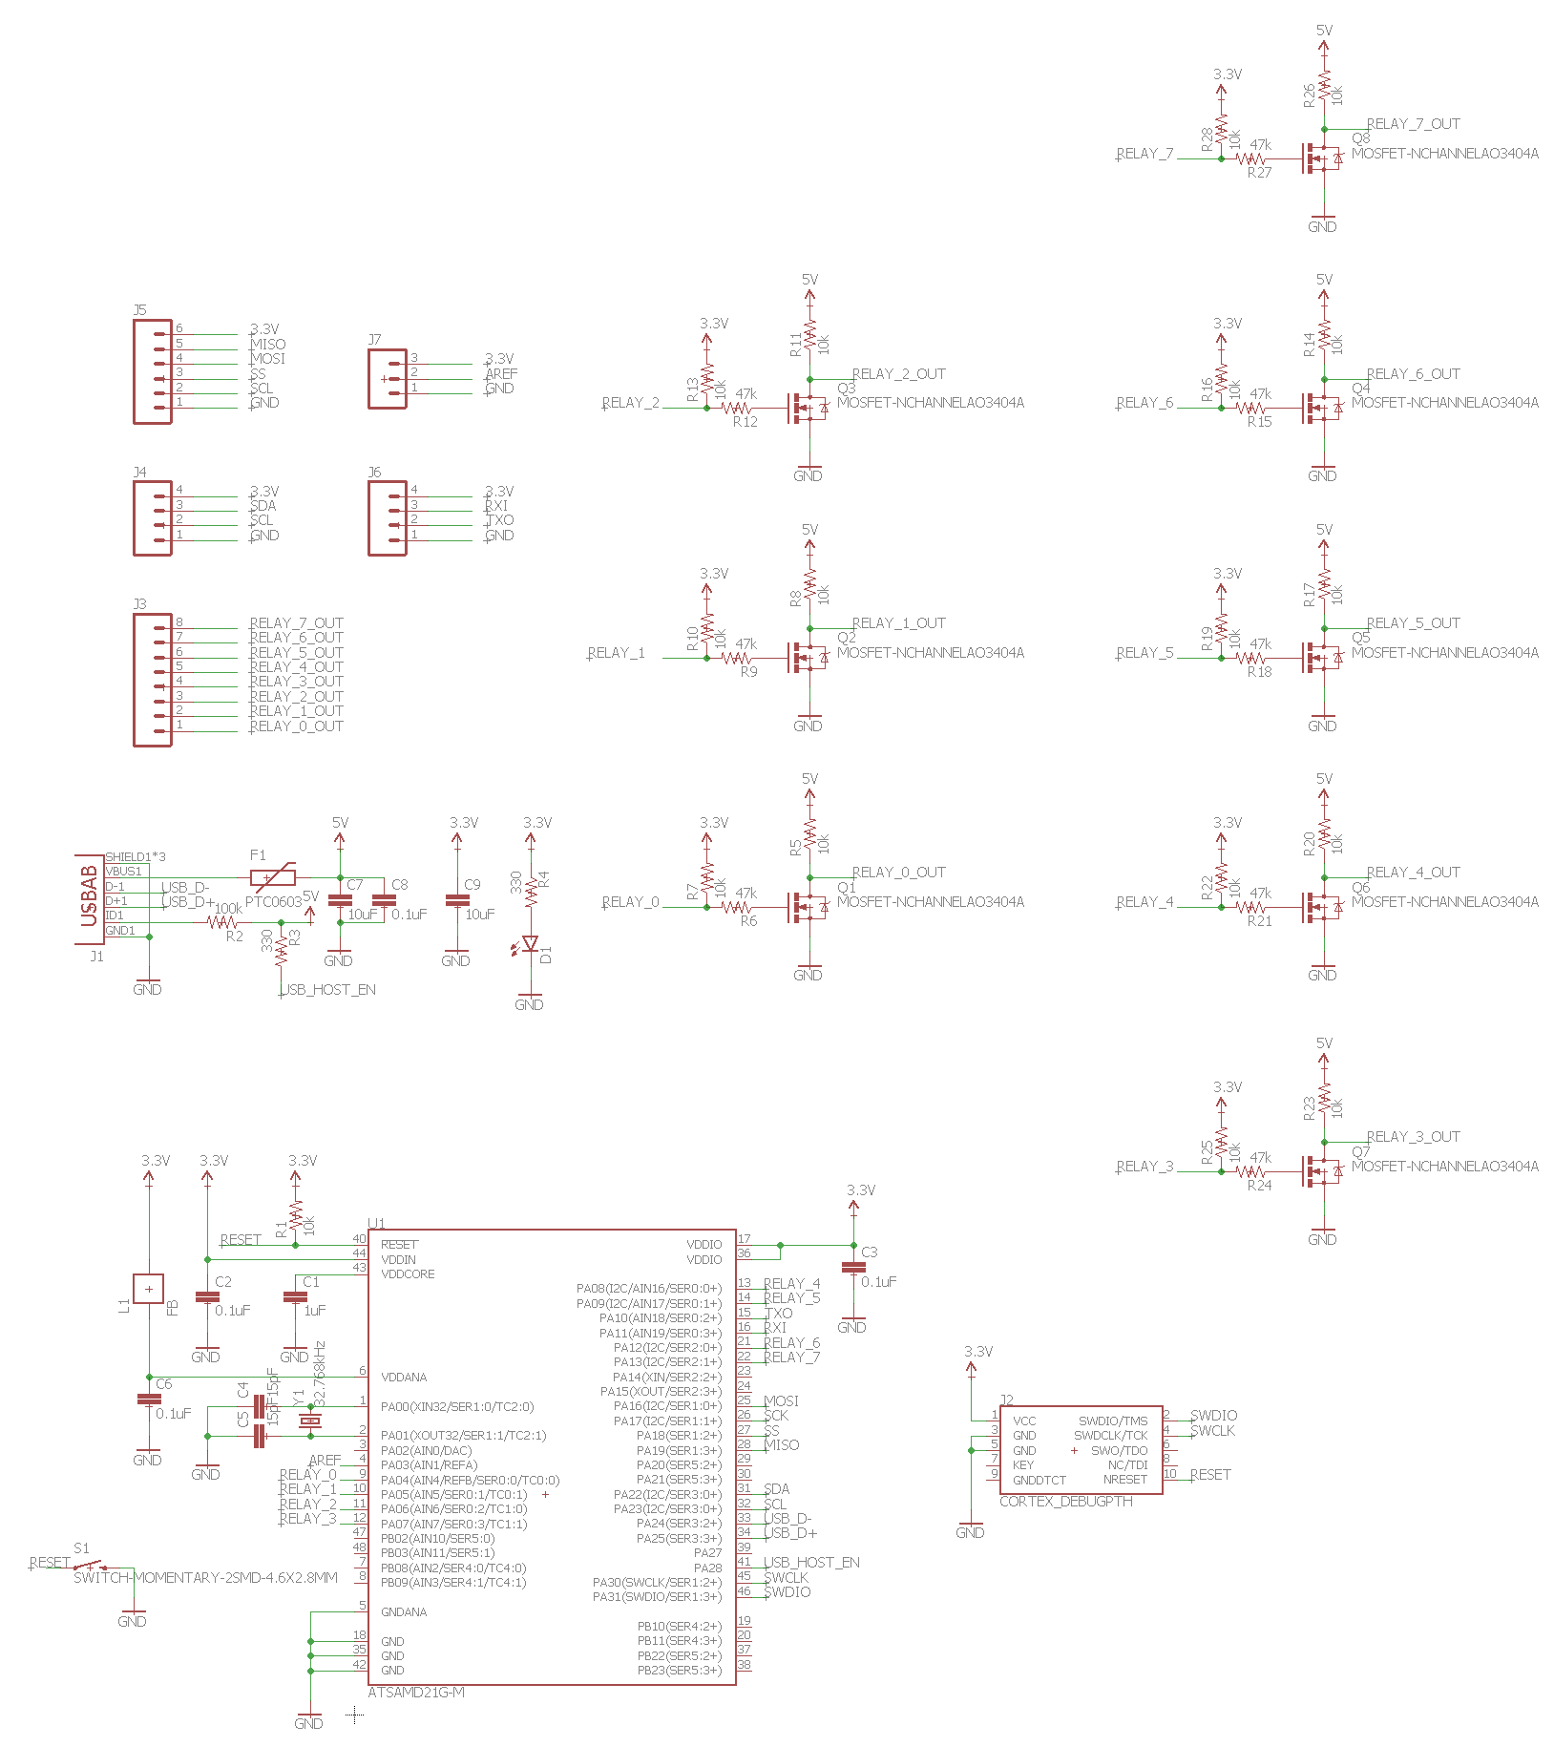**

Relay Schematic



## 

## 

## 

## 

## 

## 

## Appendix C - User Interface Diagrams

Diagram 1 - Default View



Diagram 2 - Edit View



## Appendix D - CAD Models

**8-Switch-Sized Mounting Plate**

Note: Dimensions in inches.

****

## Appendix E - Simulation Results

**Relay Simulation Results:**

The time-dependent quantity is displayed in green, while the root-mean-square (RMS) quantity is displayed in red.

*Load 1 [ 120 Ω ]*

*Voltage:*

*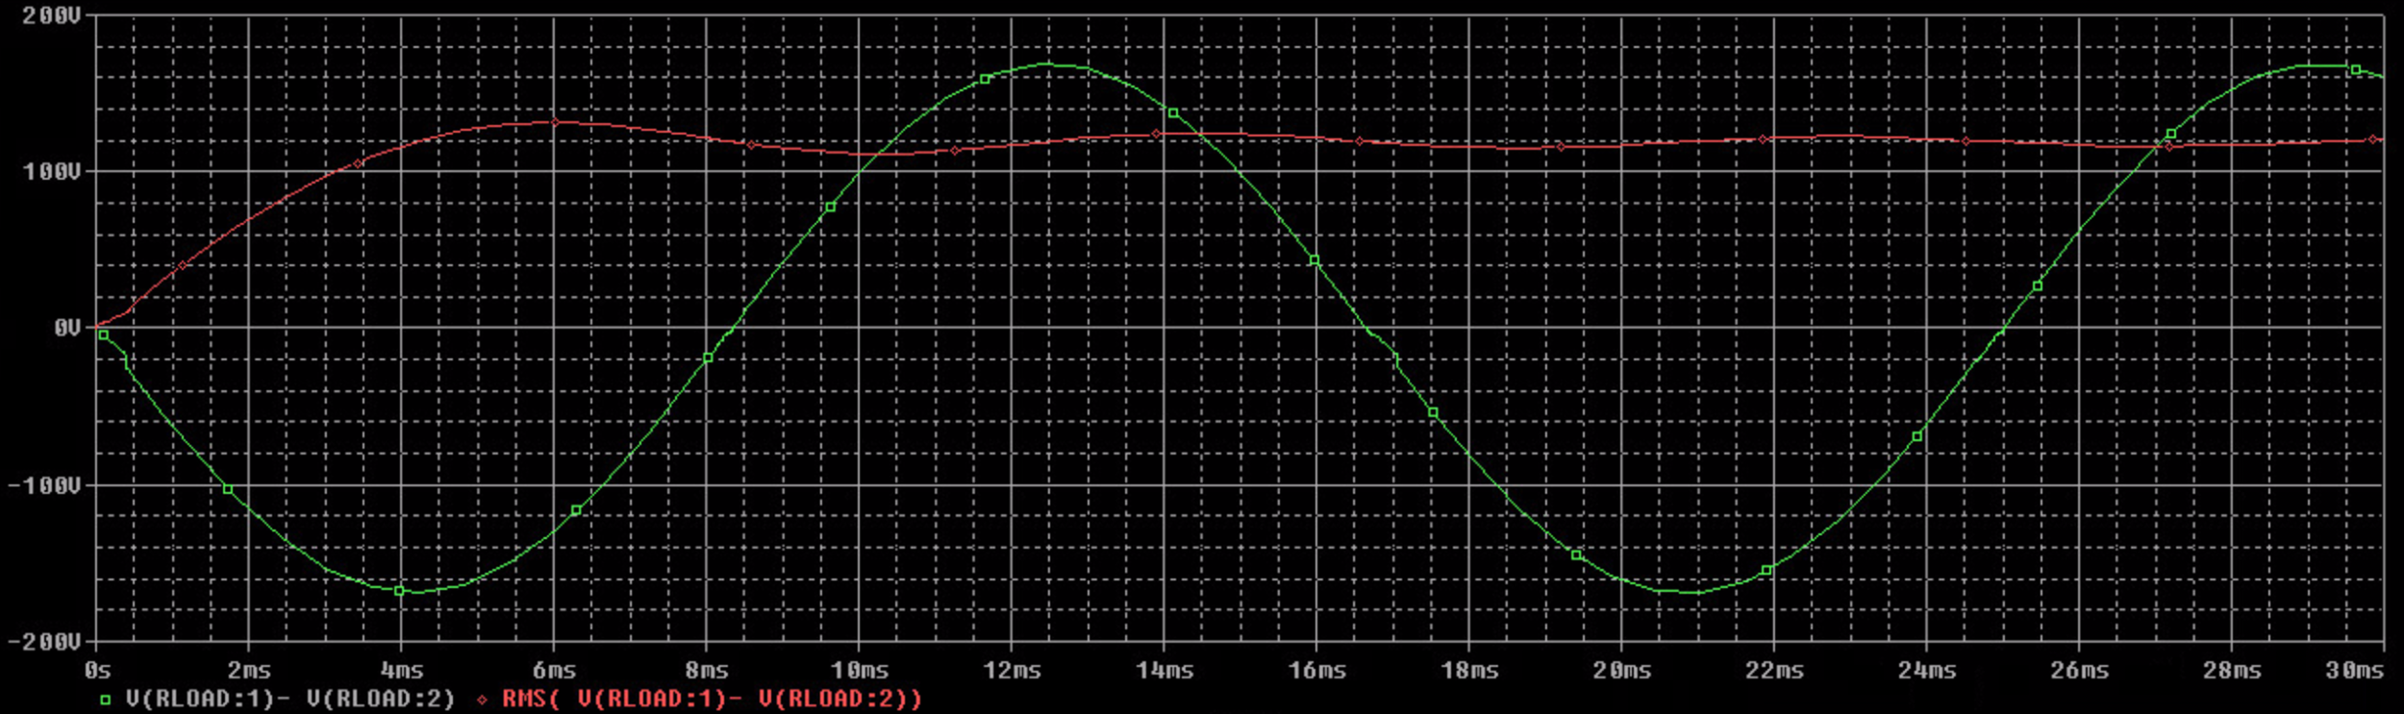*

*Current:*

*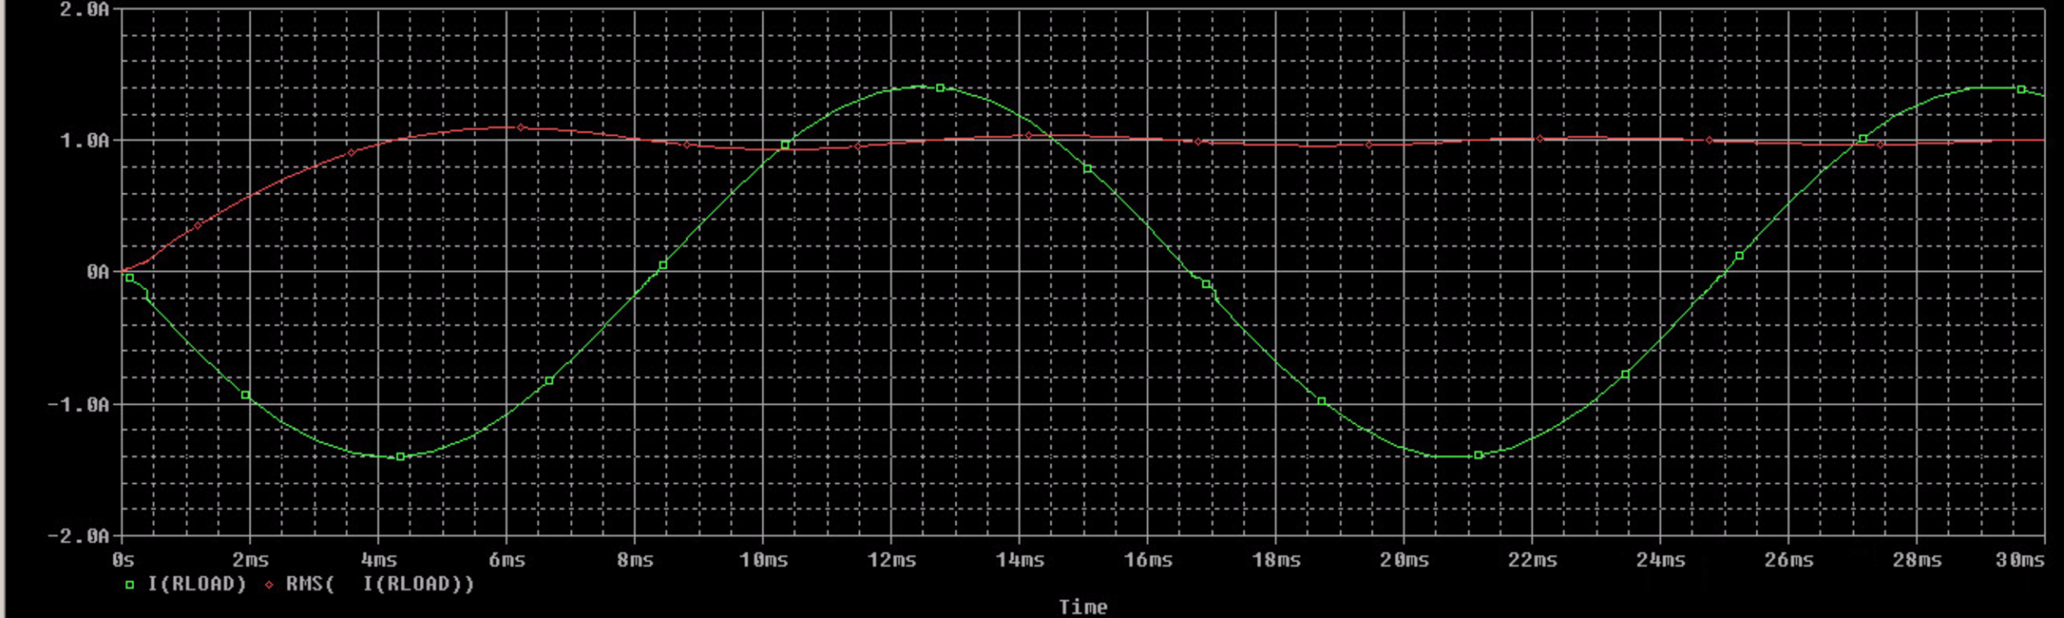*

*TRIAC Losses:*

*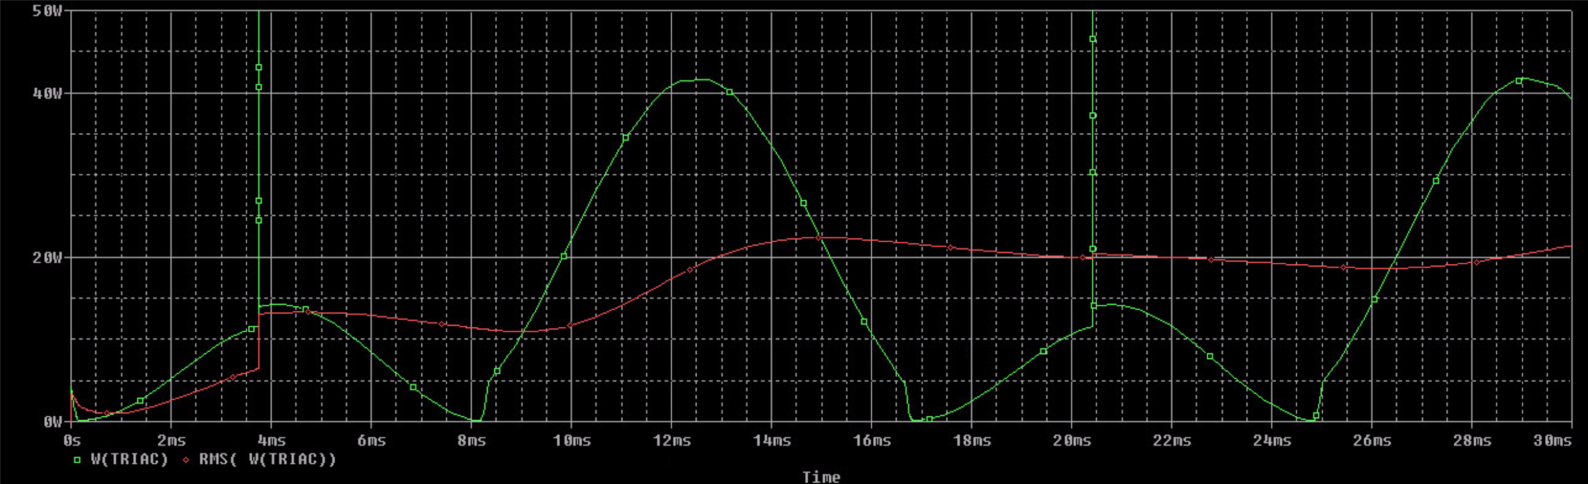*

*Load 2 [ 40 Ω ]*

*Voltage:*

*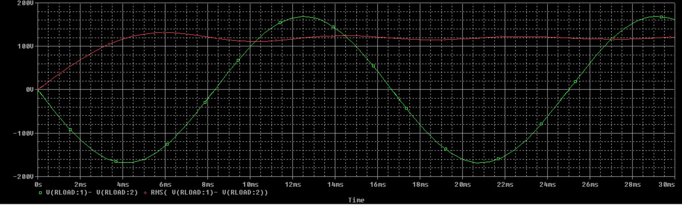*

*Current:*

*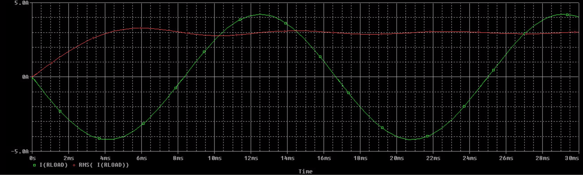*

*TRIAC Losses:*

*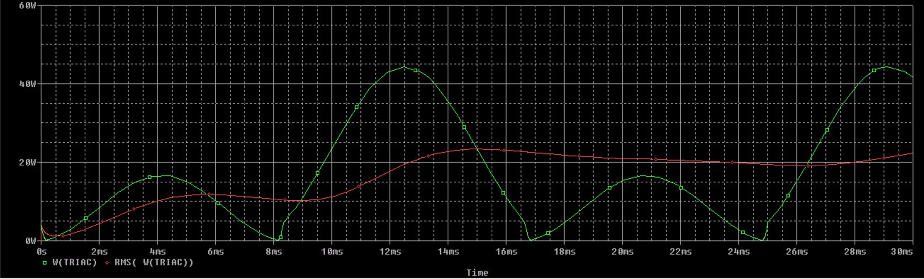*

*Load 3 [ 80 Ω ]*

*Voltage:*

*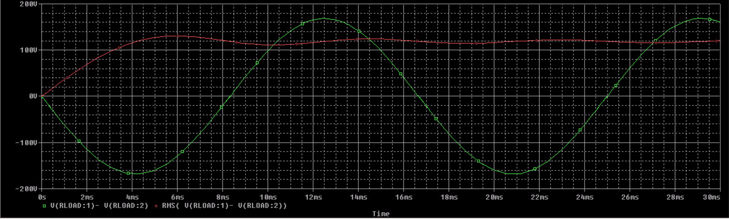*

*Current:*

*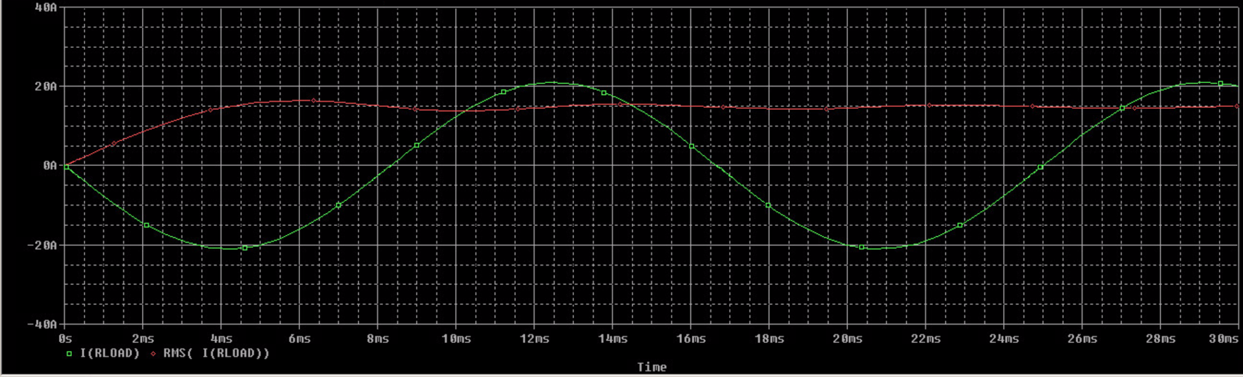*

*TRIAC Losses:*

*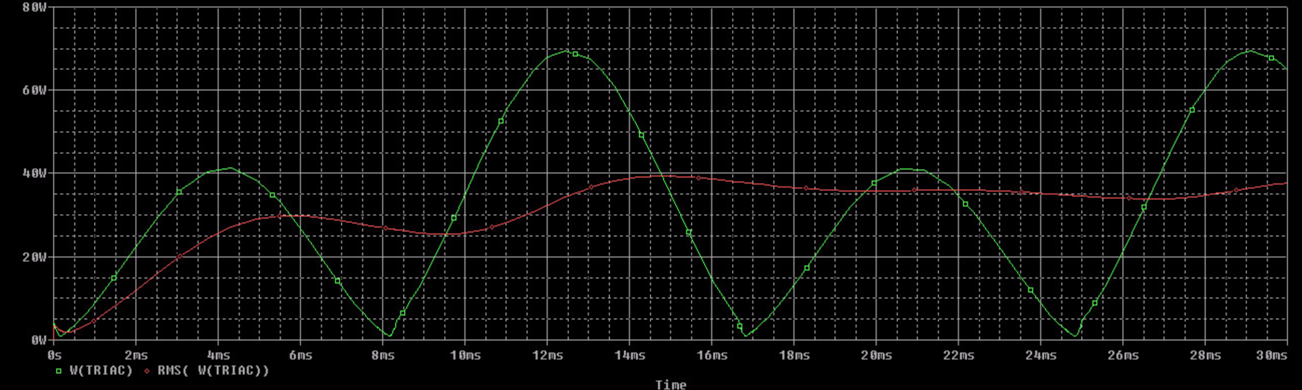*

*Load 4 [ 0.318 H ]*

*Simulation did not converge. No data.*

*Load 5 [ 0.106 H ]*

*Voltage:*

*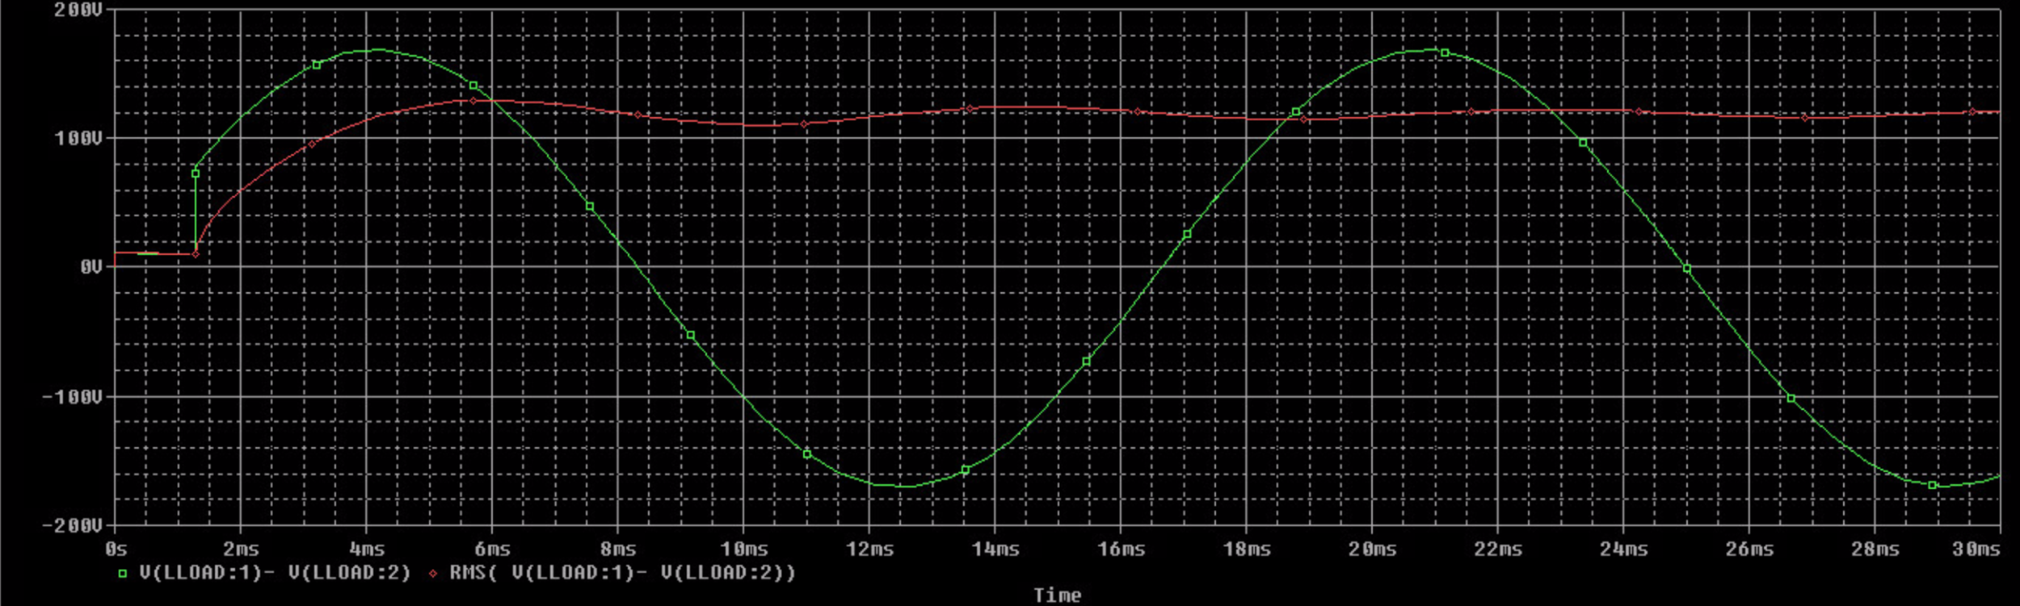*

*Current: data incomplete*

*TRIAC Losses: data incomplete*

*Load 6 [ 0.021 H ]*

*Voltage:*

*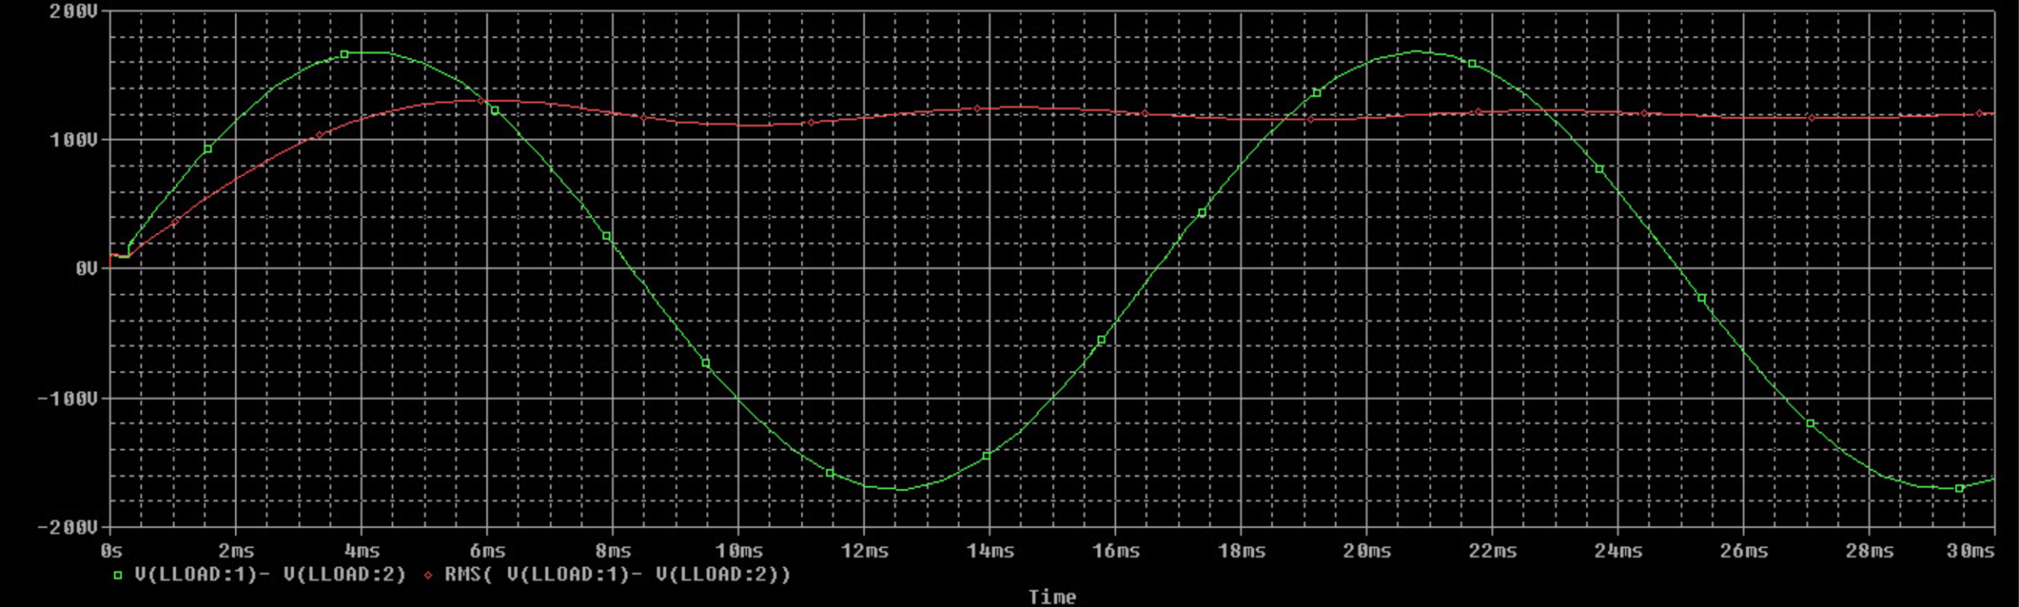*

*Current:*

*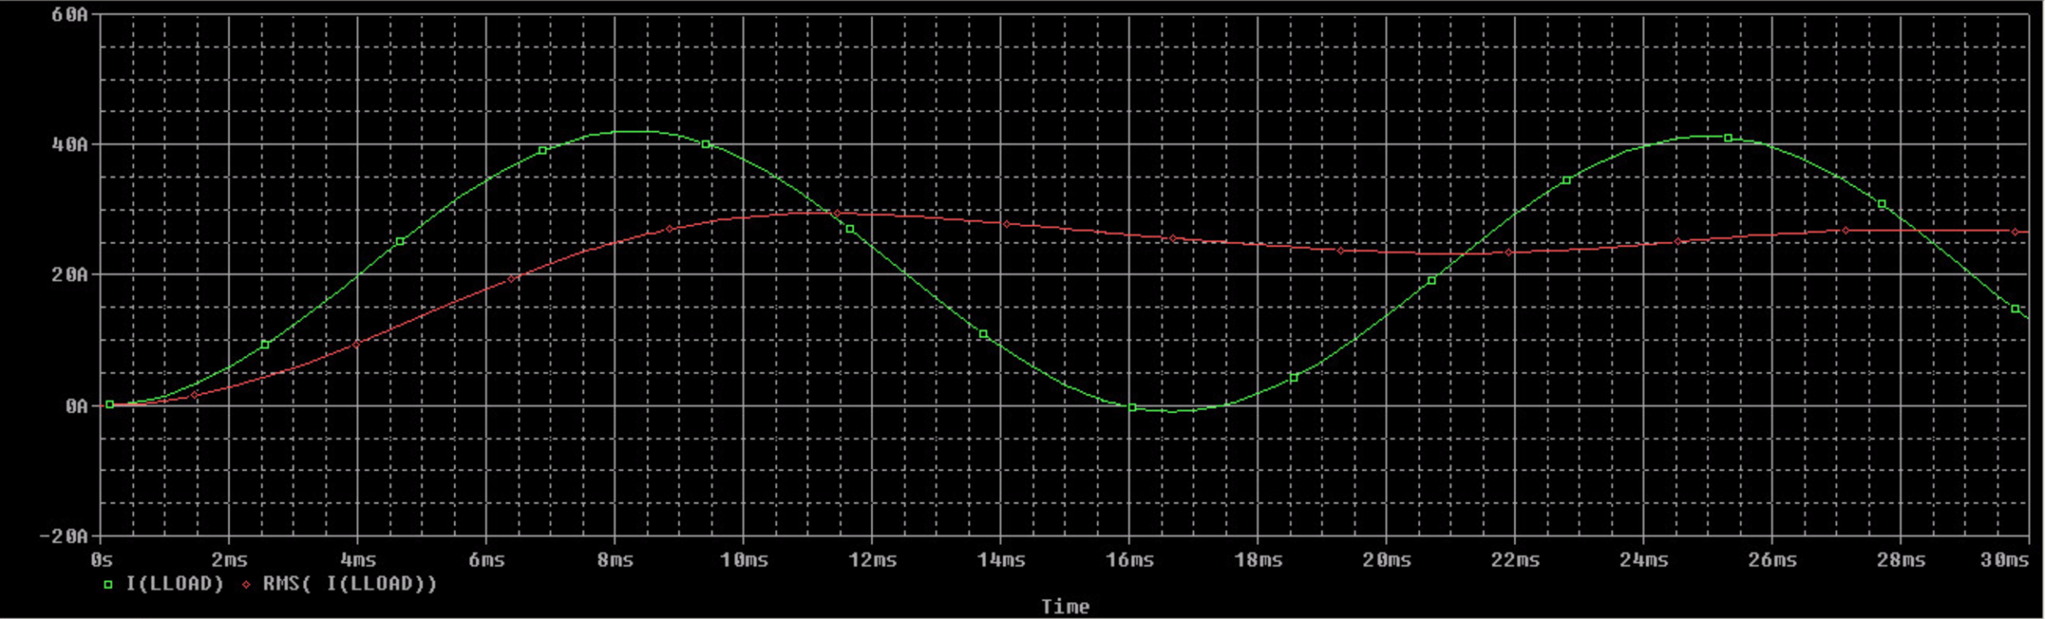*

*TRIAC Losses:*

*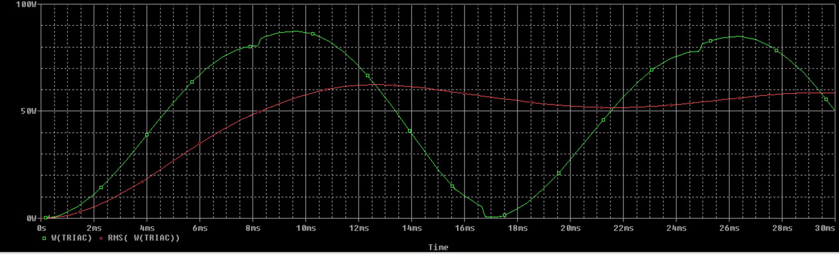*

## Appendix F - Project Schedule

